Chapter 1 – Project Background

1.1 Introduction
Graduate education involves long-term academic and research work that requires continued coordination among graduate students, advisers, panel members, coordinators, and Graduate School offices. Unlike many undergraduate processes that often move in more synchronized batches, graduate students may progress at different speeds across admission, enrollment, coursework, leave of absence and readmission, practicum where applicable, research milestones, withdrawal, and graduation endorsement. Students may move forward at different times depending on reviews, approvals, revisions, and scheduling. Because of this, student progress is not only about completing requirements. It also depends on passing milestone stages, getting approvals, and coordinating with different roles. In this kind of setting, the practical question, “Where is the student right now?” becomes difficult to answer when records and updates are scattered across different tools, offices, and communication channels.
In graduate school operations, milestone-based tracking is important for maintaining visibility and consistency across programs. Young et al. (2024) explain that graduate progress is often centered on milestones and may not fit the same kind of dashboards used for undergraduate monitoring. This suggests that institutions need tracking approaches that reflect different program rules and non-linear progress patterns. In the same way, doctoral monitoring literature shows that progress oversight depends on structured signals and not only on informal judgment (Brooks, 2023). When progress evidence is divided across admissions records, enrollment records, monitoring sheets, forms, decisions, and schedules spread across email threads, shared drives, and spreadsheets, status visibility often becomes a best-guess reconstruction instead of a clear and reliable record.
In response to this need, the proposed capstone is an AI-enhanced business system in the form of a web-based Graduate Student Lifecycle Monitoring and Analytics Platform. As an AI system, it is designed to support Graduate School work by bringing student monitoring, milestone tracking, document tracking, scheduling, follow-ups, and reporting into one platform. It also includes an AI-supported feature that uses Retrieval-Augmented Generation (RAG) through NotebookLM. This allows the system to provide answers and guidance based on Graduate School policies, guidelines, and related records, instead of relying only on general AI responses. The AI feature is meant to assist staff and administrators in reviewing cases and understanding the next steps, while final decisions remain with the proper offices and authorized personnel. In this way, the capstone combines the functions of a business system for daily Graduate School processes with AI support that improves monitoring and decision support.

1.2 Organizational Profile
This project is situated in the higher education sector, specifically in graduate school administration and student lifecycle operations in the Philippine context. Graduate schools need to coordinate many roles involved in academic decisions, such as curriculum alignment, subject planning, title approval, proposal acceptance, defense outcomes, and graduation endorsement, as well as operational tasks such as routing documents, scheduling panels, tracking compliance requirements, and monitoring student status across different stages of the lifecycle. These processes are shaped by institutional policies, program-level differences, and role restrictions related to privacy and academic records.
The main organizational setting of this project is the University of St. La Salle Graduate School in Bacolod City. The Graduate School offers programs in several academic areas, including Arts and Sciences, Business, Education, Engineering and Technology, and Nursing. Because of this, Graduate School processes must support multiple disciplines that may differ in curriculum structure, documentation requirements, practicum needs, research milestones, and review or scheduling practices.

In terms of admissions, the Graduate School follows a structured set of steps and requirements. Applicants are asked to submit requirements through the Graduate School admissions email, create an AIMS applicant account, pay the required processing and examination fees through the approved channels, and proceed through the examination and interview stages before acceptance is confirmed. These published steps show that Graduate School administration already relies on a mix of digital tools and coordination across multiple offices. This reflects the same kind of operational complexity that also appears later in enrollment monitoring, coursework tracking, leave of absence and readmission, research milestones, and graduation endorsement.
The Graduate School also operates within a defined administrative structure. The Graduate School overview identifies the academic officers of the unit, including the Dean, Academic Coordinators, Research Coordinators, and other related contact references. This is important because it helps clarify where decision-making authority and oversight may be located across Graduate School processes, policy interpretation, and escalation.

1.2.1 Key Stakeholders
Graduate School operations involve several stakeholders with different responsibilities and information needs across the full graduate student lifecycle. The process is not limited to thesis or dissertation stages alone. It also includes admission handoff, enrollment monitoring, curriculum alignment, coursework tracking, leave of absence and readmission, practicum for applicable programs, research milestones, withdrawal, and graduation endorsement. These activities are carried out through a series of handoffs among students, faculty, coordinators, administrative staff, and decision-making offices. Because of this, monitoring and process support must reflect both the academic side of decisions, such as subject completion, defense outcomes, and graduation readiness, and the operational side of coordination, such as routing, scheduling, document completeness, status updates, and approvals. The following stakeholders represent the main roles involved in the graduate student lifecycle and its related monitoring processes.
- Graduate Students. Graduate students move through both academic and research-related stages of the graduate lifecycle. These may include admission onboarding, enrollment, coursework completion, leave of absence or readmission when applicable, practicum for certain programs, title defense, proposal and final defense, revisions, and graduation endorsement. Their main need is clear visibility of their current stage, required documents, next steps, deadlines, and realistic time expectations. Students also need to know what is still pending and who is responsible for the next action to reduce repeated follow-ups and uncertainty.
- Research Adviser(s). Advisers guide manuscript development, provide technical and academic supervision, endorse readiness for proposal and final defense stages, and confirm revision completion when needed. Their monitoring needs include visibility of assigned students, pending review tasks, correct document versions, revision status, and upcoming or requested schedule windows.
- Academic Coordinator. The Academic Coordinator supports program compliance and day-to-day process flow by reviewing study plans, confirming curriculum alignment, identifying subject needs, endorsing required forms, and providing inputs related to panel nomination or research-stage requirements depending on institutional practice. Their monitoring needs include visibility of student status across the program, exception handling, and queues of pending endorsements, validation checks, or subject-related concerns
- Research Coordinator. The Research Coordinator supports research-stage coordination, such as panel nomination, defense scheduling, and routing of research-related decisions and requirements. Their monitoring needs include visibility of milestone status, compliance checks, adviser and panel assignments, and indicators that help identify cases needing follow-up or escalation.
- Graduate School Office Staff. Administrative staff coordinate schedules, track documents, route submissions, and maintain day-to-day visibility of student progress across different stages of the lifecycle. This may include onboarding support, enrollment-related monitoring, leave of absence and readmission records, defense-related coordination, and graduation endorsement preparation. In many cases, this role also maintains monitoring artifacts such as spreadsheets or email-based tracking. For example, the interview discussion referenced Ms. Lyra as an administrative support role for monitoring, which shows how visibility can become person-dependent when tracking relies on manual practices. Their monitoring needs include counts per stage, pending items, overdue cases, scheduling status, and turnaround-time signals that help identify bottlenecks.
- Dean. The Dean serves as a decision-making and approval authority in key parts of the graduate lifecycle. This may include leave of absence decisions, withdrawal requests, onboarding review, adviser designation, and graduation endorsement review. The Dean’s monitoring needs include visibility of cases awaiting approval, supporting documents, exception cases, and summary views that help support timely decisions.
- Faculty. Faculty members support the academic side of the graduate student lifecycle, particularly in coursework delivery, grade submission, and subject-related academic requirements. In the current process, faculty encode grades that students later view through the existing system, while the Graduate School uses the resulting signals mainly for completion and monitoring rather than detailed grade management. Their monitoring needs include visibility of class lists, assigned teaching loads, submitted grade status, and any subject-related information that affects Student Progress Management.

1.2.2 Ownership Mapping
Process Area | Sub-area | Accountable Office/Role (AS-IS) | Student View (AS-IS) | Current System (AS-IS) | In System Scope? (Yes/No)
Admission | Requirements submission | Admission Office | AIMS / admissions email | AIMS and email | No
 | Admission status confirmation | Graduate School Staff / Academic Coordinator | Graduate School | AIMS status and email | No
 | Program onboarding | Graduate School Staff / Academic Coordinator | Graduate School | Manual onboarding steps, email, and forms | Yes
Enrollment | Enrollment status confirmation | Graduate School Staff / Academic Coordinator | AIMS / Graduate School | Existing enrollment system and spreadsheets | Yes
 | Monitoring of enrolled classes | Academic Coordinator / Graduate School Staff | Graduate School |  | Yes
 | Monitoring of class changes | Academic Coordinator / Graduate School Staff | Graduate School | Enrollment platform + spreadsheets | Yes
 | Subject needs and class offering planning | Academic Coordinator | Graduate School | Manual planning, spreadsheets, and monitoring sheets | Yes
 | Academic progress tracking (course audit) | Academic Coordinator | Graduate School | AC-Student-Monitoring template / Excel | Yes
Coursework | Planned class schedule visibility | Academic Coordinator / Graduate School Staff | CANVAS / Graduate School | Existing student portal / CANVAS | Yes
 | Grade and standing summary signals | Faculty / Academic Coordinator | Graduate School | Registrar-side grade system | No
LOA & Readmission | LOA application tracking | Dean / Graduate School Staff | Graduate School | Email-based routing | Yes
 | Residency pause tracking | Graduate School Staff | Graduate School | Manual tracking and AIMS reports | Yes
 | Readmission application tracking | Graduate School Staff / Dean | Graduate School | Email and manual tracking | Yes
Thesis/Dissertations | Research milestone tracking | Research Coordinator / Graduate School Staff / Adviser | Graduate School | Research monitoring sheets and protocol forms | Yes
Practicum | Practicum hours and document tracking | Academic Coordinator / Program Coordinator | Graduate School | Manual logs, certificates, and paper submissions | Yes
Withdrawal | Withdrawal request tracking | Dean / Academic Coordinator | Graduate School | Email and manual tracking | Yes
 | Withdrawal status confirmation | Academic Coordinator / Graduate School Staff | Graduate School |  | Yes
Graduation | Graduation candidate review | Graduate School Staff / Academic Coordinator / Research Coordinator | Graduate School | Manual checklist and endorsement preparation | Yes
 | Graduation endorsement list review | Dean | Graduate School | Manual endorsement list | Yes
 | Graduation status output | Registrar |  | Registrar process and output | No

Table 1. Ownership Mapping
Table 1 shows the ownership mapping of each graduate student lifecycle process area and sub-area by identifying the accountable office or role in the current process, where the student usually refers for the transaction, the current system or document used, and whether the item is within the scope of the proposed system. This mapping helps define scope boundaries and supports the role lanes used in the AS-IS process diagrams and access control design. The mapping also reflects the confirmed setup that the proposed system is for monitoring and support, and does not replace official admissions, Registrar, or Accounting processes.

1.2.3 Graduate School Research Protocol Forms
Form ID | Form Name | Purpose | Key Monitoring Signal
Form 1 | Application for Title Defense | Title Defense Application | “Title defense application submitted” (date/time)
Form 2 | Report of Title Defense | Title Defense Outcome | “Approved title selected / disapproved” (outcome + date)
Form 3 | Application for Designation of Research Adviser | Adviser Designation Request | “Adviser designation requested”
Form 3.1 | Appointment for Research Adviser | Adviser Confirmed | “Adviser appointed” (date)
Form 3.2 | Research Timetable | Advising Setup | “Timetable submitted/approved”
Form 3.3 | Thesis/Dissertation Advising Contract | Advising Setup | “Advising contract completed”
Form 3.4 | Request for Change of Title of the Study | Exception / Change Control | “Title change requested/approved”
Form 3.1.1 | Request for Change of Research Adviser | Exception / Change Control | “Adviser change requested/approved”
Form 4 | Endorsement for Proposal/Final Defense | Defense Readiness Endorsement | “Endorsed for defense” (date)
Form 4.1 | Statistical Consultation Form | Conditional (Quantitative) | “Stat consultation completed”
Form 4.2 | Co-authorship Information for Publication | Conditional (Publication-related) | “Co-authorship declared”
Form 4.3 | Endorsement for Public Defense | Public Defense Readiness | “Endorsed for public defense”
Form 5 | Comments Sheet for Proposal Defense | Proposal Defense Outcome | “Proposal comments consolidated” (date)
Form 5.1 | Technical Review Certificate | Proposal Post-Revision Gate | “Technical review cleared”
Form 5.2 | Application for Ethics Review | Ethics Review | “Ethics submitted / cleared” (status + date)
Form 6 | Comments Sheet for Final Defense | Final Defense Outcome | “Final defense comments issued”
Form 7 | Evaluation Sheet for Final Defense | Final Defense Evaluation | “Final rating recorded” (pass/minor/major)
Form 8 | Settlement of Provisional Thesis/Dissertation Approval | Provisional Pass Handling | “Provisional settlement recorded”
Form 9 | Editor Certification | Manuscript Finalization | “Editor certified”
Form 10 | Approval Sheet | Completion Evidence | “Approval sheet complete” / readiness for endorsement

Table 2. Graduate School Research Protocol Forms and Their Purpose
Table 2 shows the Graduate School Research Protocol forms used in thesis and dissertation monitoring. These forms mark key process events such as applications, endorsements, comments, clearances, evaluations, and completion evidence. For monitoring purposes, each form can be linked to a milestone, owner, status, and timestamp.

1.2.4 Important Stakeholder Documents
Output | Relevance
AC-STUDENT-MONITORING-Template.xlsx | Academic year entry, student identifiers, program or track, course list, unit totals, completion markers, and AY/Sem taken fields
Student-Research-Monitoring.xlsx | Adviser assignment, milestone dates, defense outcomes, required certifications such as Turnitin, editor certification, and approval sheet, and exception notes
Graduate School Research Protocol (AY 2024–2025) | Title, proposal, and final defense stages, form flow, required documents, and conditional requirements
2nd Meeting Transcript Confirmation w/ Sir Eddie De Paula | Confirmed AS-IS process details, role ownership, scope boundaries, current monitoring practices, and key lifecycle requirements discussed with and signed by Sir Eddie De Paula.

Table 3. Source-to-mapping
Table 3 shows how key stakeholder documents support monitoring across the graduate student lifecycle. The AC-STUDENT-MONITORING template supports coursework and study plan tracking, while the student research monitoring sheet supports milestone tracking, defense outcomes, and completion evidence. The Graduate School Research Protocol provides the required forms, stages, and document requirements used in research-related processes. Together, these documents serve as practical sources for status tracking, milestone recording, and completion checking.

1.3 Description of Existing Systems
Graduate student lifecycle tracking is currently handled through a mix of existing institutional systems and manual coordination. Official records such as enrollment status and grades are kept in institutional systems, primarily AIMS, while Graduate School processes such as checking requirements, scheduling, and endorsements are often handled through email, spreadsheets, person-to-person follow-ups, the AC-Student-Monitoring template, the STUDENT-MONITORING spreadsheet, and Graduate School research protocol forms.

1.3.1 Admission
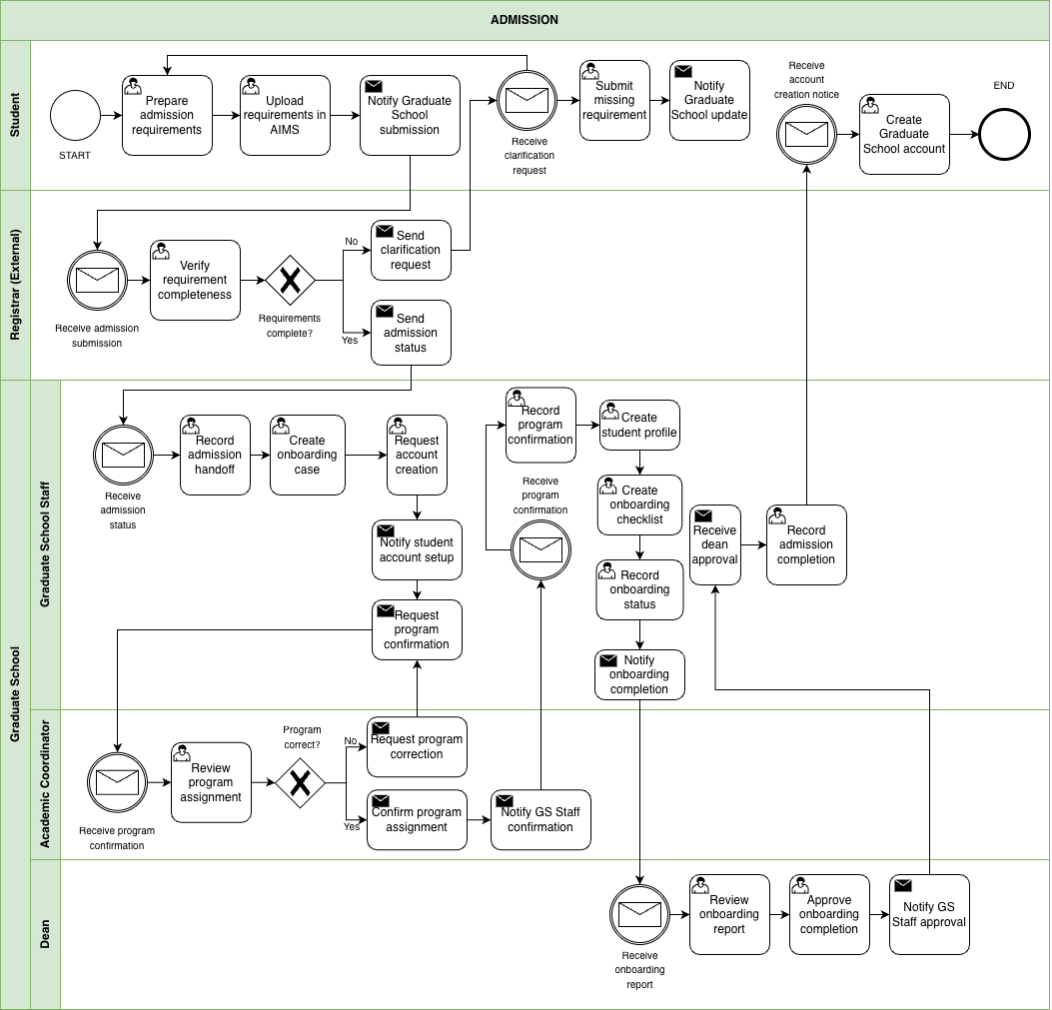

Figure 1. BPMN Diagram – Admission
This figure shows the admission monitoring handoff from AIMS to the Graduate School. The student uploads requirements in AIMS, and the Registrar checks completeness. If something is missing, a clarification request is sent and the student submits the missing items. Once admission status is confirmed, Graduate School Staff begin onboarding activities such as creating an onboarding case, requesting account creation, confirming the program assignment, and preparing an onboarding checklist. The Dean reviews onboarding completion before the Graduate School records admission completion.

1.3.2 Enrollment
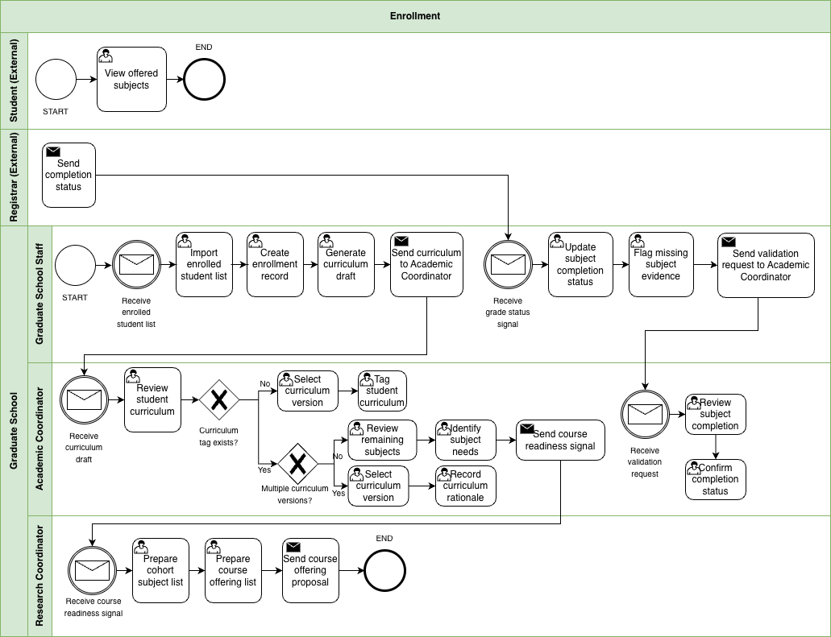

Figure 1.1 BPMN Diagram – Enrollment
This figure shows how the Graduate School takes enrollment signals and turns them into monitoring actions. Graduate School Staff receive the enrolled student list and create basic enrollment records and a curriculum draft. The Academic Coordinator reviews the curriculum, confirms or assigns the correct curriculum version, and tags the student to that curriculum. This monitoring view is based on records such as the AC-Student-Monitoring template and the STUDENT-MONITORING spreadsheet. When there are multiple curriculum versions, extra checking is needed to make sure the student is aligned correctly. After tagging, the Academic Coordinator identifies the remaining subjects and subject needs. When grade or completion signals arrive, Graduate School Staff update subject completion status, flag missing evidence, and send validation requests when needed.

1.3.3 Course Adjustments
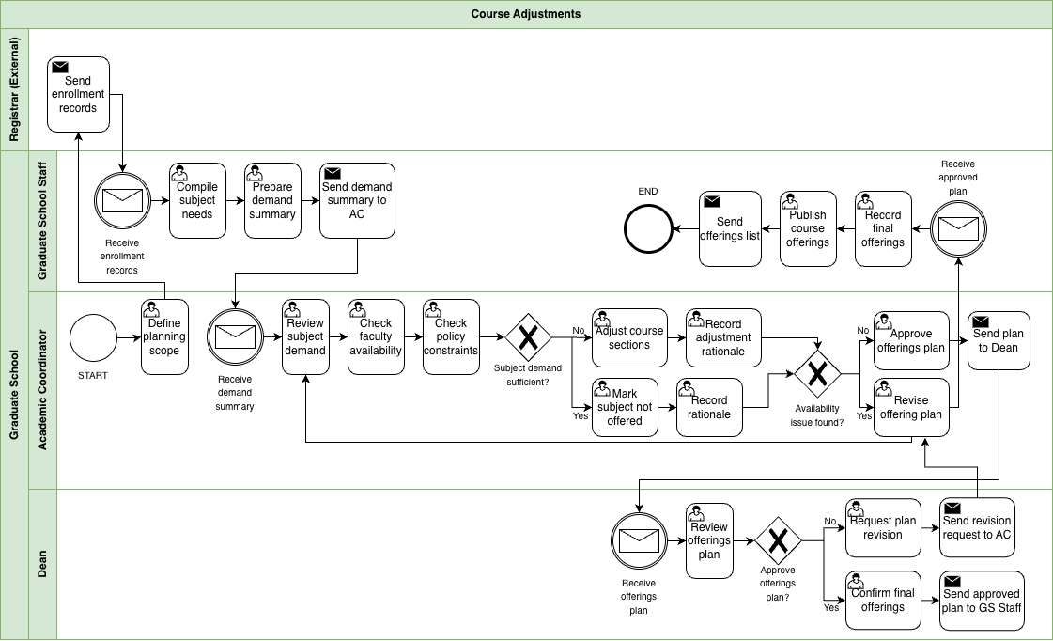

Figure 1.2 BPMN Diagram – Course Adjustments
This figure shows how the Graduate School reviews subject demand and adjusts planned course offerings before publication. Graduate School Staff compile subject needs from enrollment records and prepare a demand summary for the Academic Coordinator. The Academic Coordinator reviews subject demand, checks faculty availability and policy constraints, and decides whether to adjust course sections or mark a subject as not offered. If availability issues occur, the offering plan is revised before being sent to the Dean for approval. Once approved, Graduate School Staff record the final offerings and publish the course list. This reflects the current practice where the Academic Coordinator prepares course offerings based on student subject needs and curriculum requirements near the end of each term.

1.3.4 Coursework
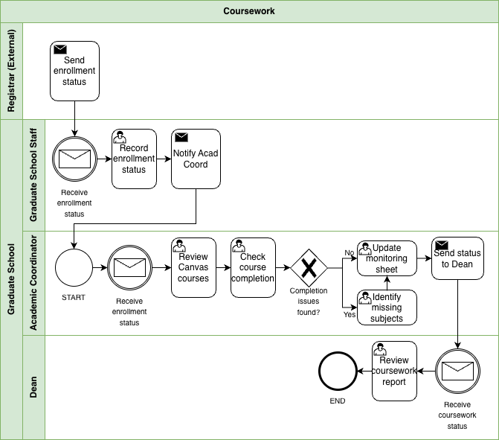

Figure 1.3 BPMN Diagram – Coursework
This figure shows how the Graduate School monitors coursework completion after enrollment. Enrollment status is received from existing institutional records, and Graduate School Staff record the status and notify the Academic Coordinator. The Academic Coordinator reviews coursework and checks subject completion to identify missing subjects or remaining requirements. Monitoring records are updated and the coursework status is sent to the Dean for review. This process reflects how Graduate School monitoring focuses on completion status and remaining subjects rather than exact grade values while official academic records remain within the Registrar’s system.

1.3.5 Leave of Absence and Readmission
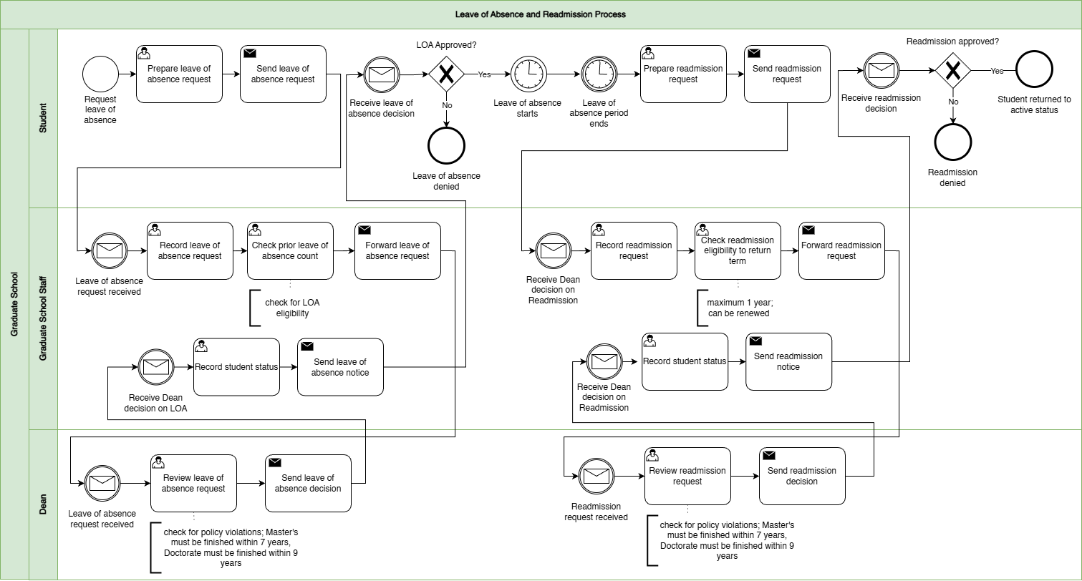

Figure 1.4 BPMN Diagram – Leave of Absence and Readmission
This figure shows leave of absence and readmission as a stop and start process. The student submits a leave of absence request, usually through email, and Graduate School Staff record it, check eligibility including prior leave of absence count, and forward it to the Dean for approval. Once the Dean decides, Graduate School Staff record the student’s status and send the decision notice. The stop and start part is important because leave of absence has an approved period, and readmission happens later when the student is ready to return. When the student requests readmission, staff record the request, check eligibility to return for the target term, and forward it again to the Dean. After the Dean’s decision, staff update the status and notify the student.

1.3.6 Title Defense
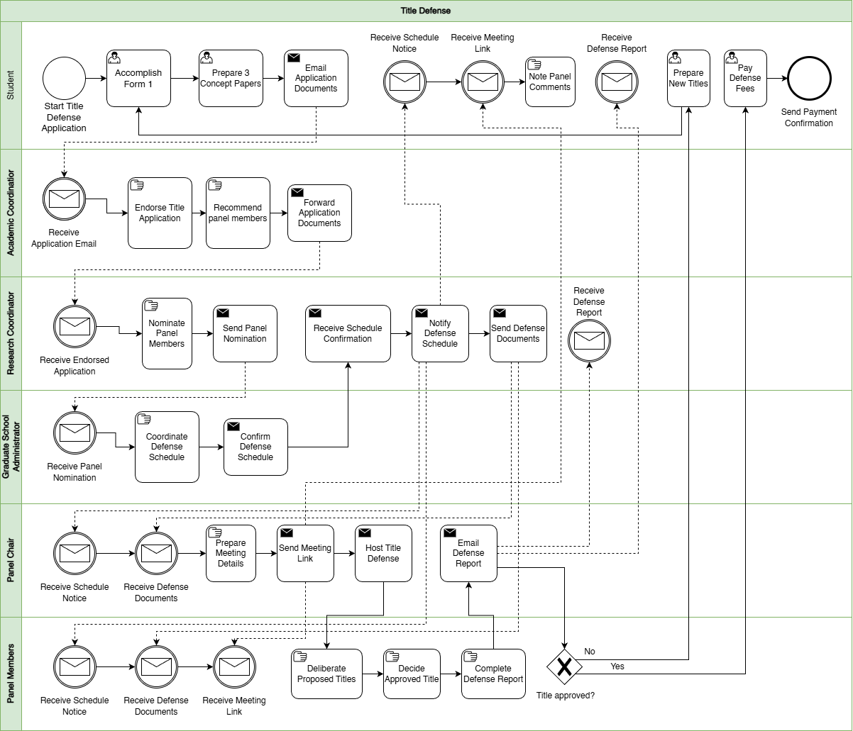

Figure 1.5 BPMN Diagram – Title Defense
This figure shows how the title defense application and decisions are coordinated. The student prepares and submits the required documents, including the concept papers, Form 1 Application for Title Defense, and the related application materials. The Academic Coordinator receives the submission, endorses it, and helps recommend panel members. The Research Coordinator handles panel nomination. Graduate School administration coordinates the schedule and sends notices. The Panel Chair prepares the meeting details, sends the meeting link, hosts the title defense, and sends the defense report through Form 2 Report of Title Defense. The Panel Members deliberate and decide whether the proposed title is approved. If the title is not approved, the student revises and prepares new titles for re-evaluation. If approved, the student proceeds with the next required actions, including payment, which is usually given in cash to the panel on the day of the defense.

1.3.7 Advisor Designation
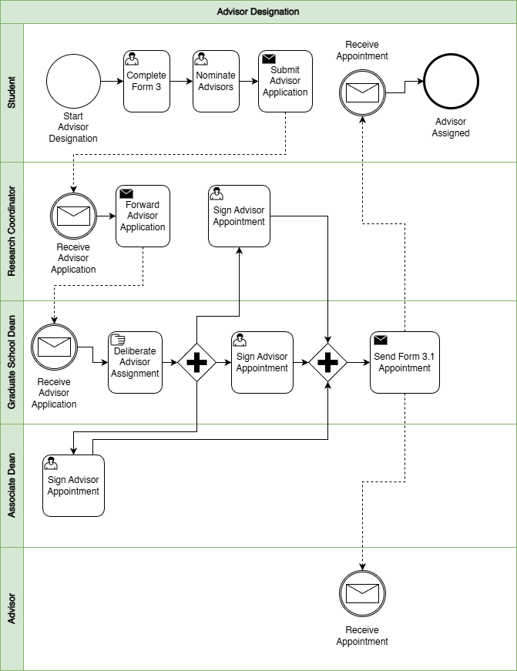

Figure 1.6 BPMN Diagram – Advisor Designation
This figure shows the adviser assignment process from student nomination to official appointment. The student completes Form 3 Application for Designation of Research Adviser and nominates advisers, then submits the adviser application. The Research Coordinator receives and forwards the application. The Graduate School Dean reviews and deliberates adviser assignment, and the appointment is signed and confirmed. After signing, Form 3.1 Appointment for Research Adviser is sent out, and both the student and adviser receive the appointment. After the adviser is confirmed, related advising setup documents such as Form 3.2 Research Timetable and Form 3.3 Thesis/Dissertation Advising Contract may also be completed as part of the advising setup.

1.3.7 Defense Scheduling and Rescheduling
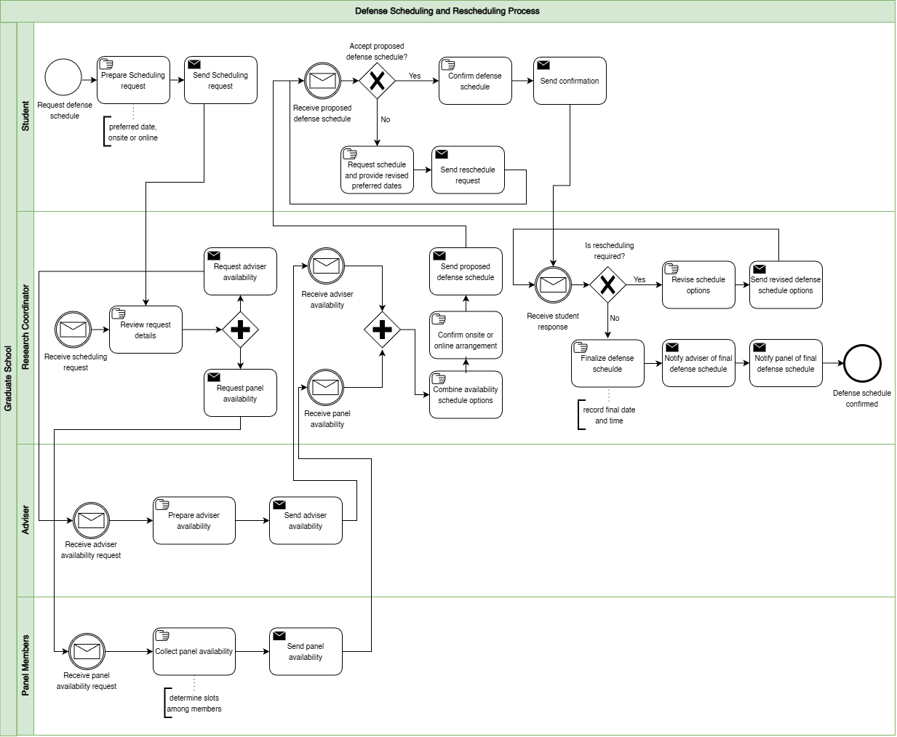

Figure 1.7 BPMN Diagram – Defense Scheduling and Rescheduling
This figure isolates defense scheduling as a coordination loop. The student submits a schedule request with a preferred date window and mode, either onsite or online. The Research Coordinator reviews the request and collects availability from the adviser and panel members. Once availability is received, the Research Coordinator combines it into schedule options, confirms the venue or online arrangement, and sends a proposed schedule to the student. The student either confirms or requests a reschedule with revised preferred dates. If rescheduling is required, the Research Coordinator revises options and the loop repeats. If confirmed, the schedule is finalized and notifications are sent to the adviser and panel. In the wider research process, this scheduling stage usually happens alongside defense readiness documents such as Form 4 Endorsement for Proposal/Final Defense and, when applicable, Form 4.3 Endorsement for Public Defense.

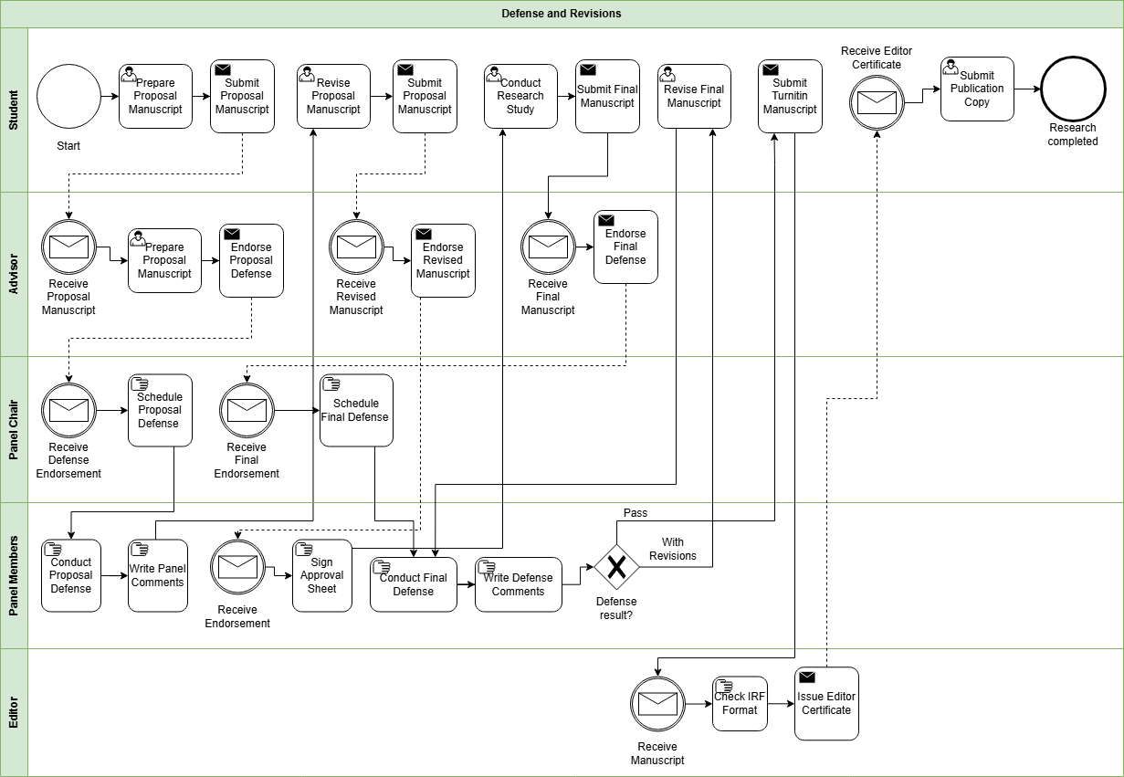
1.3.9 Defense and Revisions

Figure 1.8 BPMN Diagram – Defense and Revisions
This figure focuses on what happens after a defense decision and how revisions are handled. After the defense, panel comments and required revisions are captured and routed back to the student. Depending on the stage, this may involve documents such as Form 5 Comments Sheet for Proposal Defense, Form 6 Comments Sheet for Final Defense, and Form 7 Evaluation Sheet for Final Defense. If there is a provisional pass or conditional approval, Form 8 Settlement of Provisional Thesis/Dissertation Approval may also be used. The student revises and resubmits until the required changes are confirmed as complete. If revisions are incomplete or unclear, the process loops back for further updates. Related completion and clearance documents may also appear in this stage, including Form 5.1 Technical Review Certificate, Form 5.2 Application for Ethics Review, Form 9 Editor Certification, and Form 10 Approval Sheet.

1.3.10 Practicum
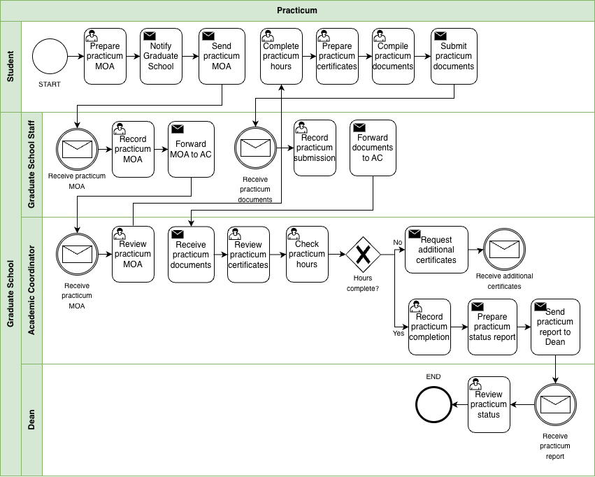

Figure 1.9 BPMN Diagram – Practicum
This figure shows how the Graduate School monitors practicum requirements for programs that require field hours. Practicum currently applies only to the Psychology and Master of Science in Guidance and Counseling (MSGC) programs, so this workflow functions as a conditional process that activates only when practicum is required. The student first notifies the Graduate School and submits the practicum MOA before completing the required practicum hours. After completing the hours, the student submits practicum certificates and supporting documents. Graduate School Staff record the submission and forward the documents to the Academic Coordinator. The Academic Coordinator reviews the certificates and checks whether the required practicum hours are completed. Because hours may be completed across multiple companies, several certificates may need to be reviewed. Once the requirement is satisfied, the Academic Coordinator records completion and sends a practicum status report to the Dean for review.

1.3.11 Withdrawal
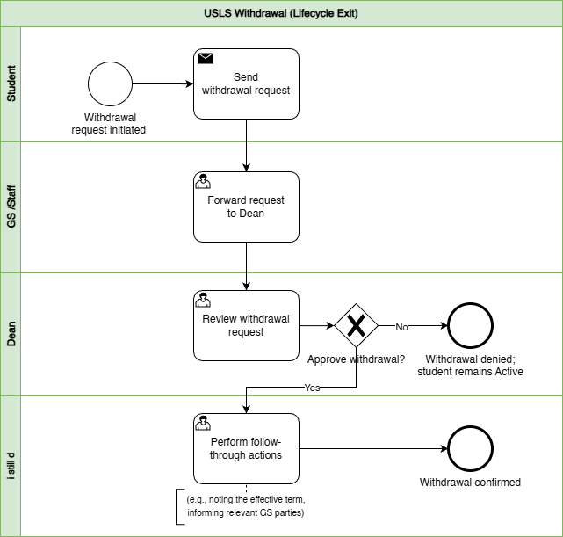

Figure 1.10 BPMN Diagram – Withdrawal
This figure shows withdrawal as a controlled exit process. The student submits a withdrawal request, Graduate School Staff forward it to the Dean, and the Dean approves or denies the request. If denied, the student remains active. If approved, follow-through actions are performed, such as noting the effective term and informing relevant Graduate School parties, and the withdrawal is confirmed.

1.3.12 Graduation
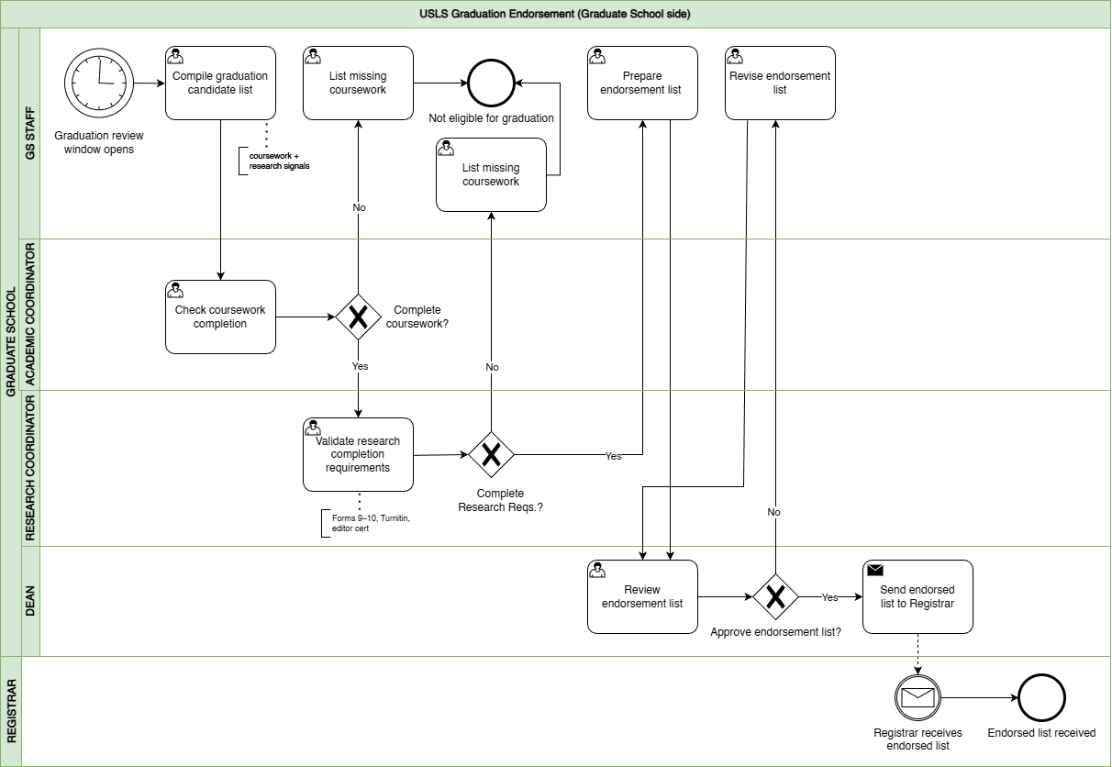

Figure 1.11 BPMN Diagram – Graduation
This figure shows graduation as an endorsement process on the Graduate School side, separate from Registrar graduation processing. Graduate School Staff compile a candidate list during the graduation review window. The Academic Coordinator checks coursework completion, and the Research Coordinator validates research completion requirements. This validation may include completion evidence drawn from the research protocol documents, especially Form 9 Editor Certification and Form 10 Approval Sheet, together with other credited subject and requirement checks. If requirements are missing, the student is marked not eligible and is placed under missing requirements tracking so the issue is visible instead of being lost in follow-ups. If complete, an endorsement list is prepared and sent to the Dean for review. If approved, the endorsed list is sent to the Registrar and the receipt is acknowledged.

1.4 Statement of the Problem
Graduate schools must maintain oversight of graduate student progression across the full graduate student lifecycle to support academic decisions, compliance monitoring, and timely intervention for delayed cases. This includes admission handoff, enrollment monitoring, coursework tracking, leave of absence and readmission, practicum for applicable programs, research milestones, withdrawal, and graduation endorsement. In current practice, however, graduate student lifecycle monitoring and processes are performed through manual coordination using multiple records and documents.
Information needed to verify a student’s standing is distributed across different files and tools maintained by various Graduate School stakeholders. For example, admissions results are recorded in spreadsheets, enrollment and coursework progress are tracked in monitoring sheets, and research-related requirements such as Form 4 (Research Protocol Submission Form) are reviewed by the academic coordinator and faculty advisers. Other supporting records, such as practicum documents and email coordination, are also used in monitoring. Because each stage of the process is recorded separately, confirming a student’s progress requires checking several files and communicating with multiple stakeholders.
As a result, stakeholders cannot easily determine key monitoring information such as the current lifecycle stage of a student, pending requirements, the responsible person for the next action, or which cases may already be delayed. Confirming this information often requires manual checking of records, reviewing forms, and coordinating through email or follow-ups.
This concern was also raised during the second confirmed meeting with Sir Eddie De Paula, documented in the review and sign-off file titled 2nd Meeting Transcript Confirmation w/ Sir Eddie De Paula. In that meeting, the Graduate School identified the need for reports such as subject needs for class planning, lists of graduating students, LOA monitoring, and residency tracking. The notes also confirm that staff sometimes generate reports from AIMS and still manually compute residency by counting the student’s start and end years, which takes more time and effort. In addition, the current monitoring view is often kept per student in spreadsheets rather than in one consolidated group view, so reporting still requires manual consolidation before it can support decisions. This shows that the issue is not simply solved by adding more manpower. Even if more people are assigned to do the work, the process remains manual, slower, more costly, and still prone to encoding errors, missed updates, and inconsistent results.
Main Problem Statement: “Graduate student status is recorded across multiple sources, and the Graduate School does not have one consolidated view. Because monitoring and processing rely on manual checking and encoding, status confirmation is slow and prone to human error.”
This means:
- Difficulty in maintaining a clear view of student progress. Graduate School tracking covers many stages of the student lifecycle and research milestones. Stakeholders need a clear view of where a student stands to support term decisions, compliance checks, and early intervention for delayed cases.
- Difficulty in receiving updates and supporting evidence on time. Status details come from different sources such as admissions signals, monitoring sheets, protocol forms, and email coordination. Because updates rely on manual checking and encoding, some updates may be delayed, missed, or recorded incorrectly.
- Difficulty in combining records into one status view. Even when the needed information exists, it is stored in separate tools and records. Staff often need to piece these together to confirm student standing and readiness, which takes time and effort.
- Difficulty in answering basic monitoring questions quickly. Without one shared view, stakeholders cannot quickly determine where the student is now, what is pending or overdue, who owns the next action, and which cases may be delayed without manual checking and reconciliation.
- Difficulty in acting early when confirmation is slow. When status confirmation takes too long, follow-ups and decisions are also delayed. This can lead to repeated follow-ups and slower response to stalled cases.
- Difficulty in generating timely and reliable reports. The Graduate School needs reports such as subject needs for class planning, lists of graduating students, LOA monitoring, and residency tracking. However, these are still pulled from separate records and manually combined. In some cases, staff still have to compute residency manually from AIMS reports, which takes time and increases the risk of delay and human error.

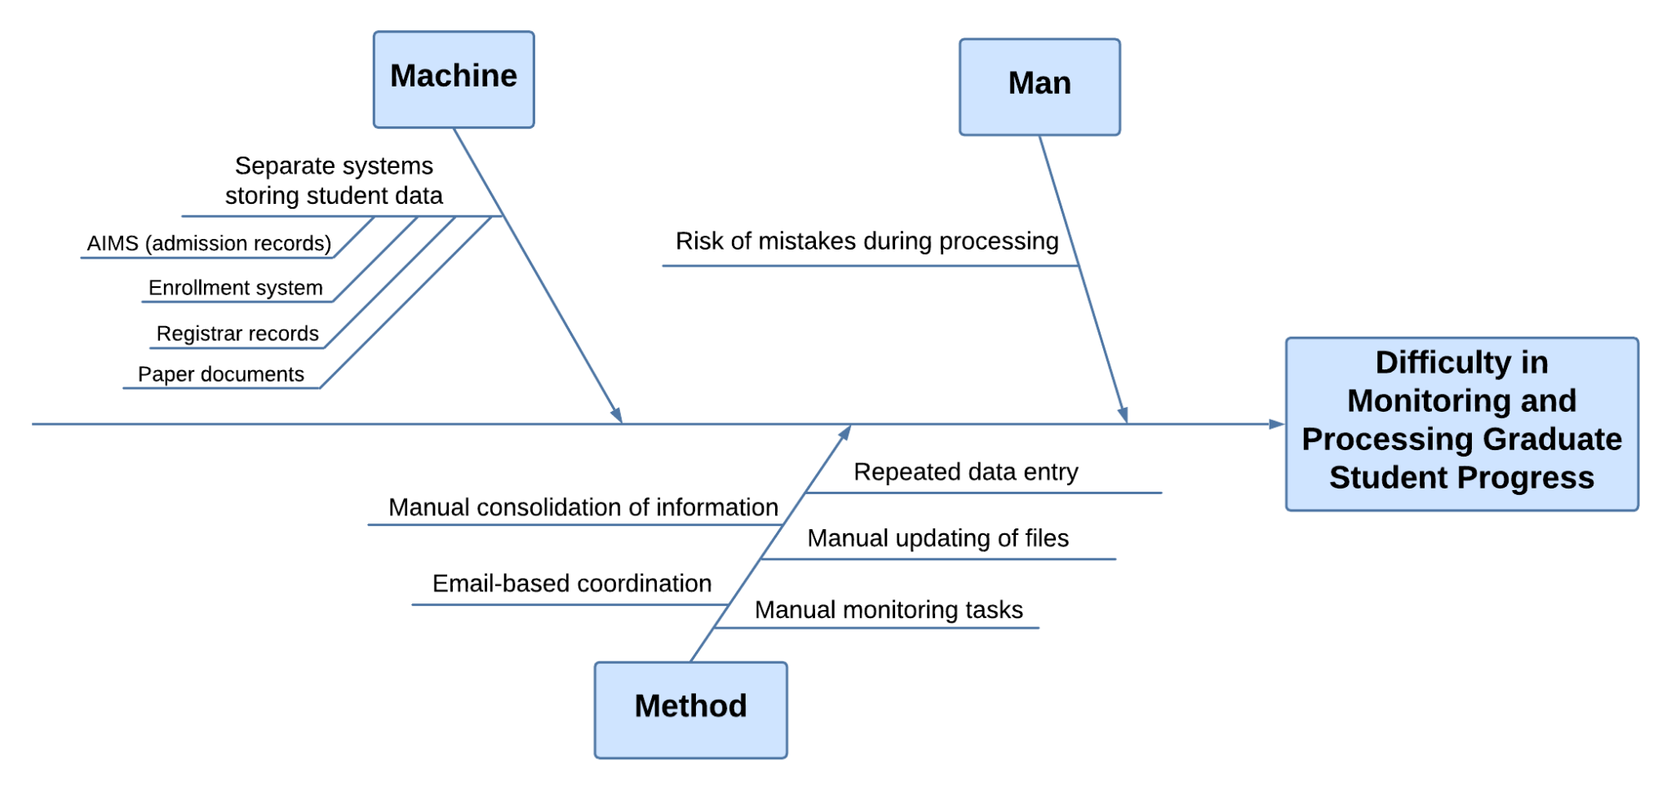

Figure 2. Ishikawa Diagram – Root Causes of Difficulty in Monitoring and Processing Graduate Student Progress
The difficulty in monitoring and processing graduate student progress is primarily caused by issues related to the systems used, the monitoring process, and the risk of errors during handling. Under the Machine category, student information is stored in separate systems such as AIMS for admission records, the enrollment system, registrar records, and paper documents. Because each system contains only a portion of the student lifecycle, staff are unable to view a complete and consolidated status in one place. This fragmentation requires them to access multiple sources when verifying student progress, which slows down monitoring and contributes to inefficiency.
Under the Method category, the monitoring process relies heavily on manual handling of information. Staff must manually consolidate information by gathering data from different records and combining them to confirm student status. Updates are also handled through manual file updates and repeated data entry, as the same information needs to be encoded across multiple records. In addition, coordination is done through email, which further delays communication and follow-ups. These practices make the monitoring process time-consuming and dependent on manual effort.
Under the Man category, the reliance on manual processes increases the risk of mistakes during processing. Because staff repeatedly encode and update information across multiple files, there is a higher chance of errors such as incorrect entries or missed updates. These errors can lead to inconsistencies in student records and affect the accuracy of monitoring. Altogether, the separation of systems, manual processes, and risk of human error contribute to inefficiencies and inconsistencies, which makes it difficult for the Graduate School to effectively monitor and process graduate student progress.
These root causes show why graduate student progress is difficult to monitor and process consistently, and why status confirmation and report generation often depend on delayed and manually combined information (Sorour & Atkins, 2024; CHED Region IV-B MIMAROPA, 2018).
These conditions make it difficult to maintain a consistent view of students standing across lifecycle stages and research milestones. Because process events, evidence requirements, ownership of next actions, and timestamps are kept across separate records and handled through manual coordination, Graduate School staff often need repeated checking, follow-up, and reconciliation just to confirm the current status of a case. This also makes pending items, delays, time in stage, scheduling status, and workload visibility harder to monitor reliably (Grooms et al., 2016; Sorour & Atkins, 2024; Datu, 2022; Tanate-Lazo, 2021).

1.5 Objectives of the Study
This study aims to analyze graduate school operations in order to identify operational inefficiencies that affect lifecycle monitoring and decision support. Specifically, it intends to:
- Understand and analyze graduate school operations to identify inefficiencies affecting lifecycle monitoring, follow-ups, and coordination of graduate student progress. (Grooms et al., 2016; CHED Region IV-B MIMAROPA, 2018)
- Identify the most appropriate solution to address the problem of divided monitoring signals and delayed status confirmation for Graduate School stakeholders. (Sorour & Atkins, 2024; Sancon, 2023)
- Design and implement modules that address the identified problems and sub-processes by enabling consistent capture of process events, evidence, next-action ownership, and timestamps. (Datu, 2022; Doce & Ching, 2018; Purcia & Velarde, 2022)
- Develop analytics outputs that match Graduate School monitoring needs such as dashboards, reports, queue aging, bottleneck indicators, process indicators, and rule-based next-action prompts. (Sorour & Atkins, 2024; Sancon, 2023)
- Conduct appropriate testing to verify the requirements of the Graduate School and confirm the platform supports its intended users. (Brooks, 2023; van Lill, 2024)

1.5.1 SDG Alignment (Sustainable Development Goals):
- SDG 4 – Quality Education: The study supports quality graduate education by making student progress easier to monitor, helping offices identify delayed cases earlier, and guiding timely follow-up so students can move through requirements and milestones more consistently.
- SDG 9 – Industry, Innovation and Infrastructure: The study supports digital improvement in graduate school operations by developing a centralized platform that brings together scattered records into a consistent monitoring and analytics system.
- SDG 16 – Peace, Justice and Strong Institutions: The study supports stronger institutional processes by clarifying responsibility for the next step, keeping key timestamps and status evidence consistent, and producing reports that are more traceable and less dependent on manual reconciliation.

1.6 Conceptual Framework/Design Architecture

1.6.1 Conceptual Framework

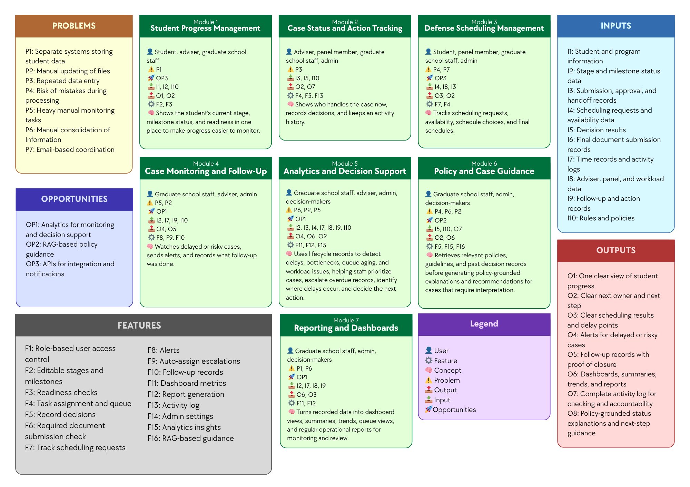

Figure 3. Conceptual Framework Diagram
The conceptual framework of the study presents the overall structure of the proposed Graduate Student Lifecycle Monitoring and Analytics Platform by linking the identified problems, opportunities, inputs, features, modules, and expected outputs. It serves as a high-level guide for understanding how the proposed system is intended to address the operational issues experienced by the Graduate School, such as Separate systems storing student data, Lack of integrated monitoring platform, Repeated data entry, Risk of mistakes during processing, Heavy manual monitoring tasks, Manual consolidation of Information, Email-based coordination, and Manual updating of files. At this stage, the framework is presented as an organizing model rather than a detailed technical design, showing the major parts of the proposed platform, how they are connected, and how they support graduate student lifecycle management. It also shows that the proposed modules and features are designed to respond directly to the identified problems while making use of the opportunities, namely Analytics for monitoring and decision support, RAG-based policy guidance, and APIs for integration and notifications. The discussion that follows explains how each module addresses specific problems, what technology can be used, and how such technology can help solve the problems and contribute to the expected outputs of the system.

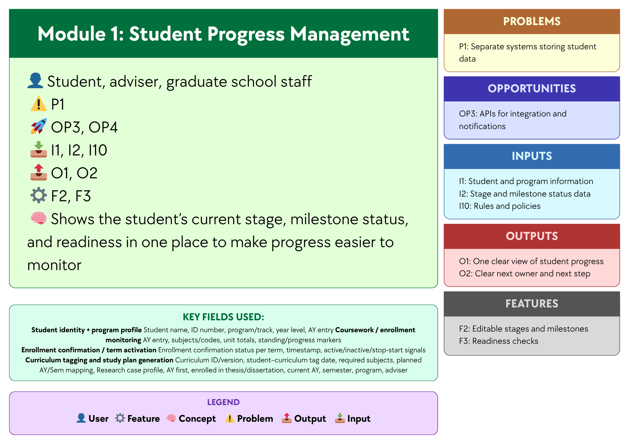

Figure 3.1 Module 1: Student Progress Management
This module focuses on providing a unified view of each student’s progress in the graduate student lifecycle by consolidating Student and program information, Stage and milestone status data, and Rules and policies. Through Editable stages and milestones and Readiness checks, the module helps address Separate systems storing student data and Lack of integrated monitoring platform by organizing progress-related records in one platform and showing the student’s current stage, milestone status, and readiness in a single view. A centralized database and a web-based monitoring interface may be used to support this module, since these technologies allow records to be stored, updated, and accessed in one place instead of across separate files or systems. In this way, the module produces One clear view of student progress and Clear next owner and next step, making progress monitoring more organized, consistent, and accessible for students, advisers, and Graduate School staff.

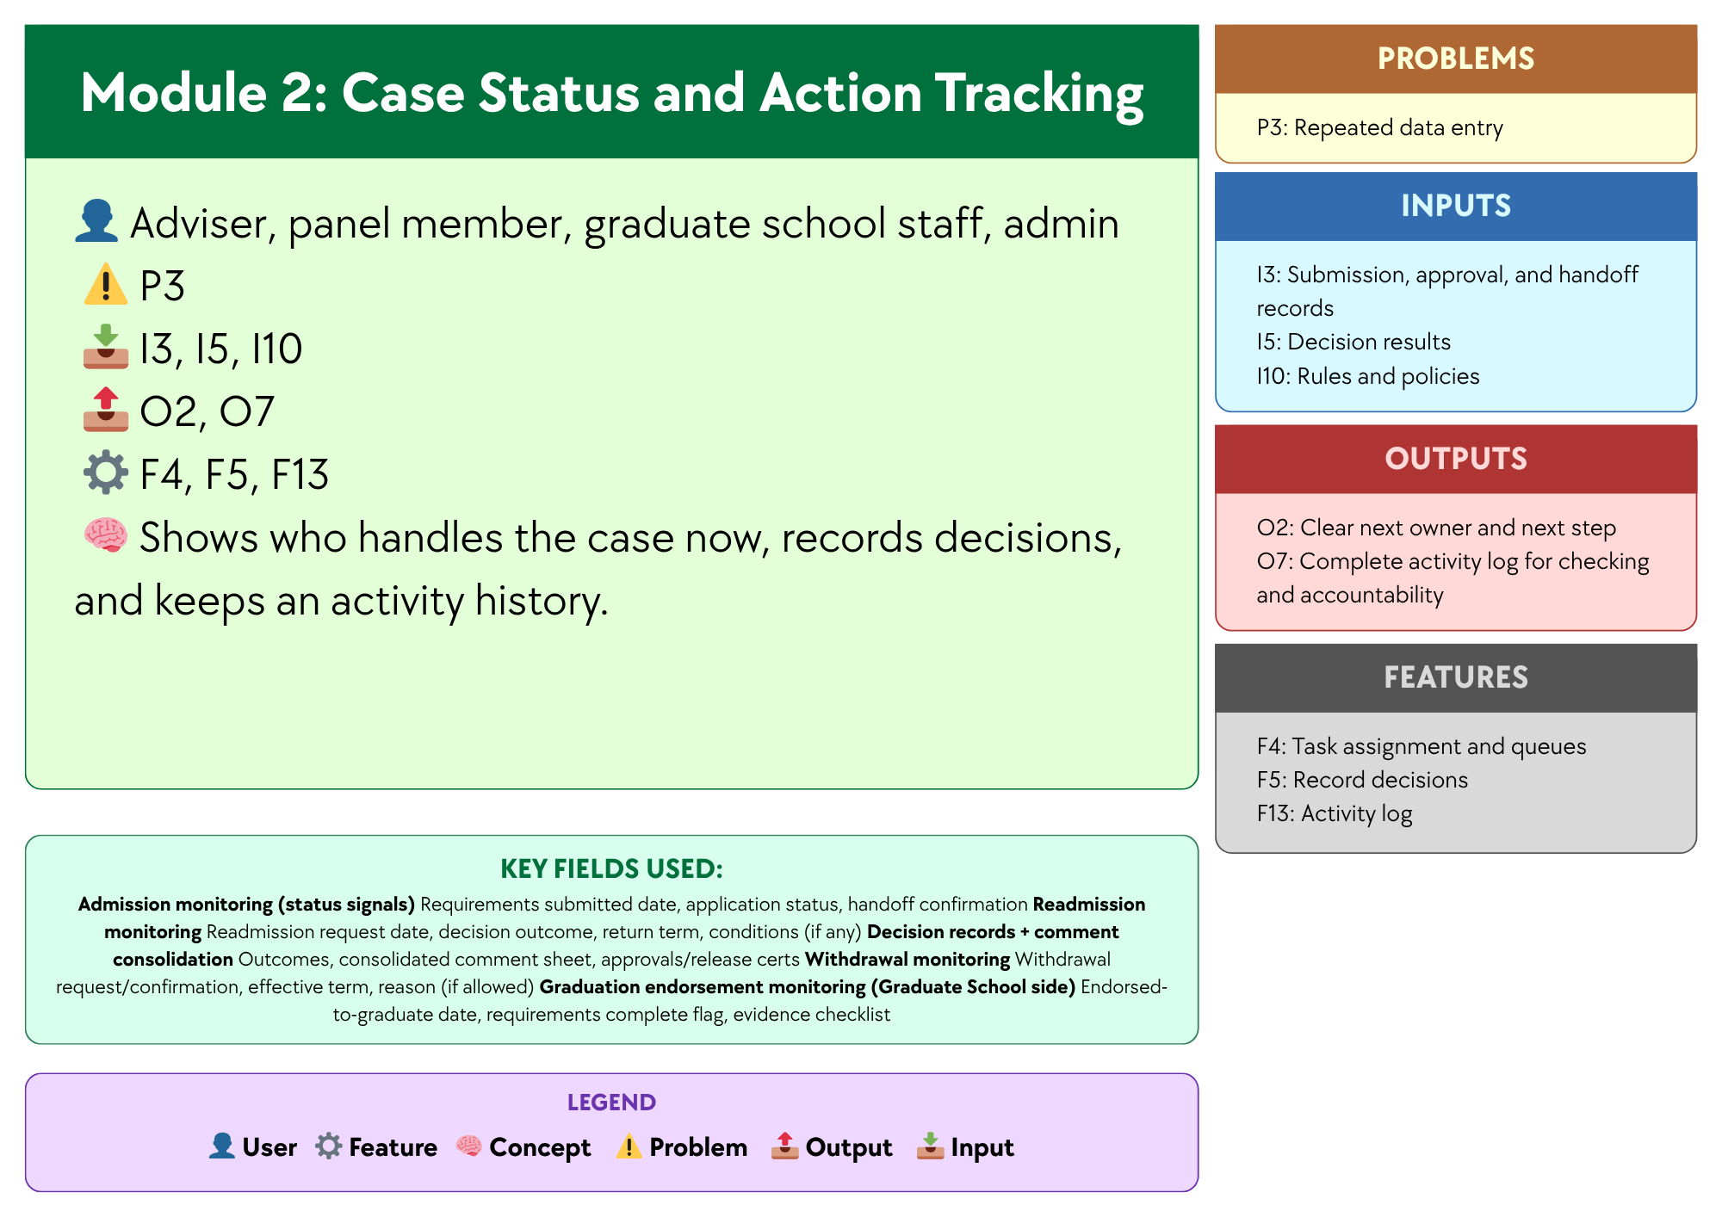

Figure 3.2 Module 2: Case Status and Action Tracking
This module focuses on recording case-related actions and status changes so users can see who currently handles the case, what action has been taken, and what should happen next. Using Submission, approval, and handoff records, Decision results, and Rules and policies, and supported by Task assignment and queue, Record decisions, and Activity log, the module helps address Lack of integrated monitoring platform and Repeated data entry by keeping case actions and records in one place instead of across separate files, emails, or manual logs. A centralized case record database and a status tracking interface may be used to support this module, since these technologies allow case updates, handoffs, and decision records to be stored and viewed in a structured and traceable way. In this way, the module produces Clear next owner and next step and Complete activity log for checking and accountability, helping improve visibility, coordination, and record consistency across the handling of graduate school cases.

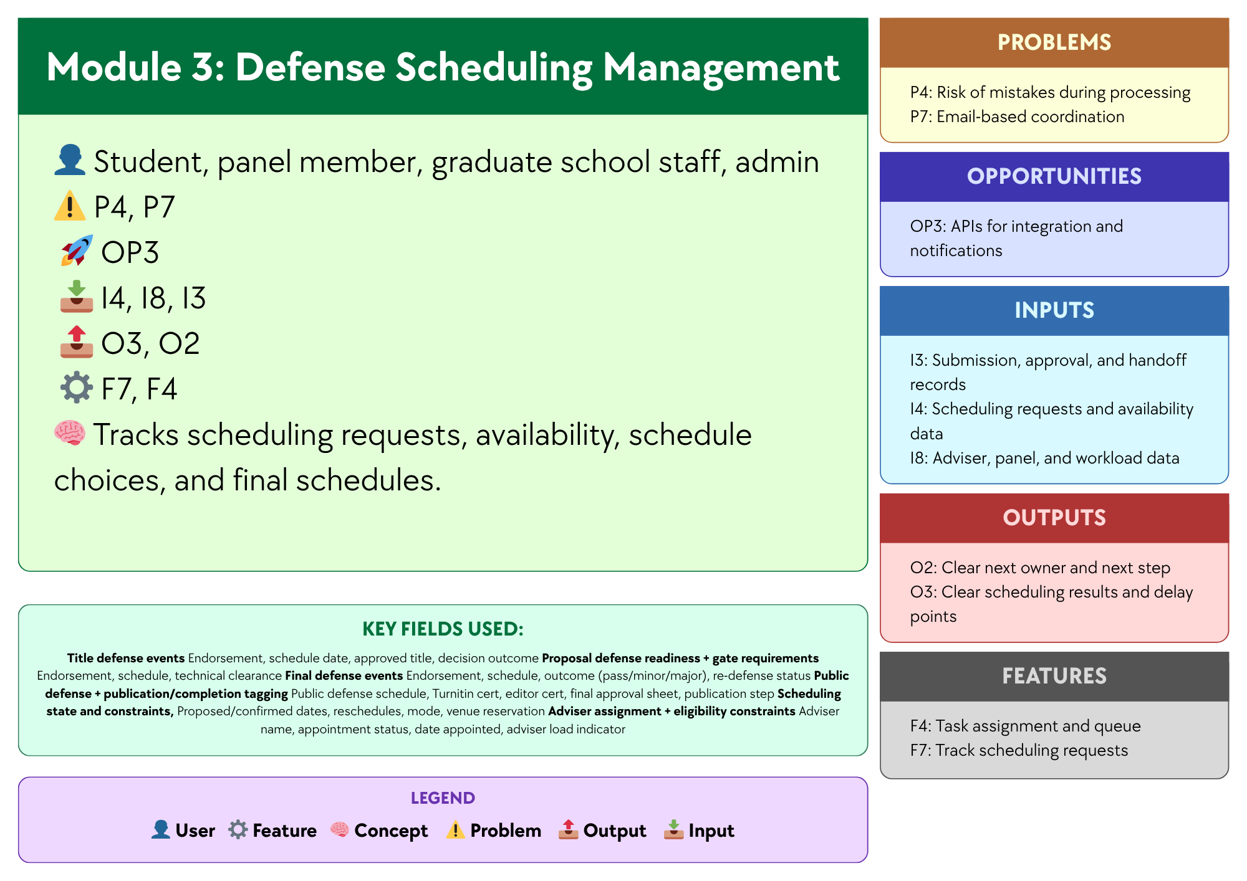

Figure 3.3 Module 3:Defense Scheduling Management
This module focuses on organizing and tracking the scheduling of defense-related activities by using Scheduling requests and availability data, Adviser, panel, and workload data, and Submission, approval, and handoff records. Supported by Track scheduling requests and Task assignment and queue, the module helps address Risk of mistakes during processing and Email-based coordination by recording schedule requests, availability, schedule choices, and final schedules in one place. A centralized scheduling database, a scheduling management interface, and APIs for integration and notifications may be used to support this module, since these technologies can help store scheduling records, match availability, and send updates or reminders to involved users. In this way, the module produces Clear scheduling results and delay points and Clear next owner and next step, making defense scheduling more organized, visible, and easier to coordinate among students, panel members, and Graduate School staff.

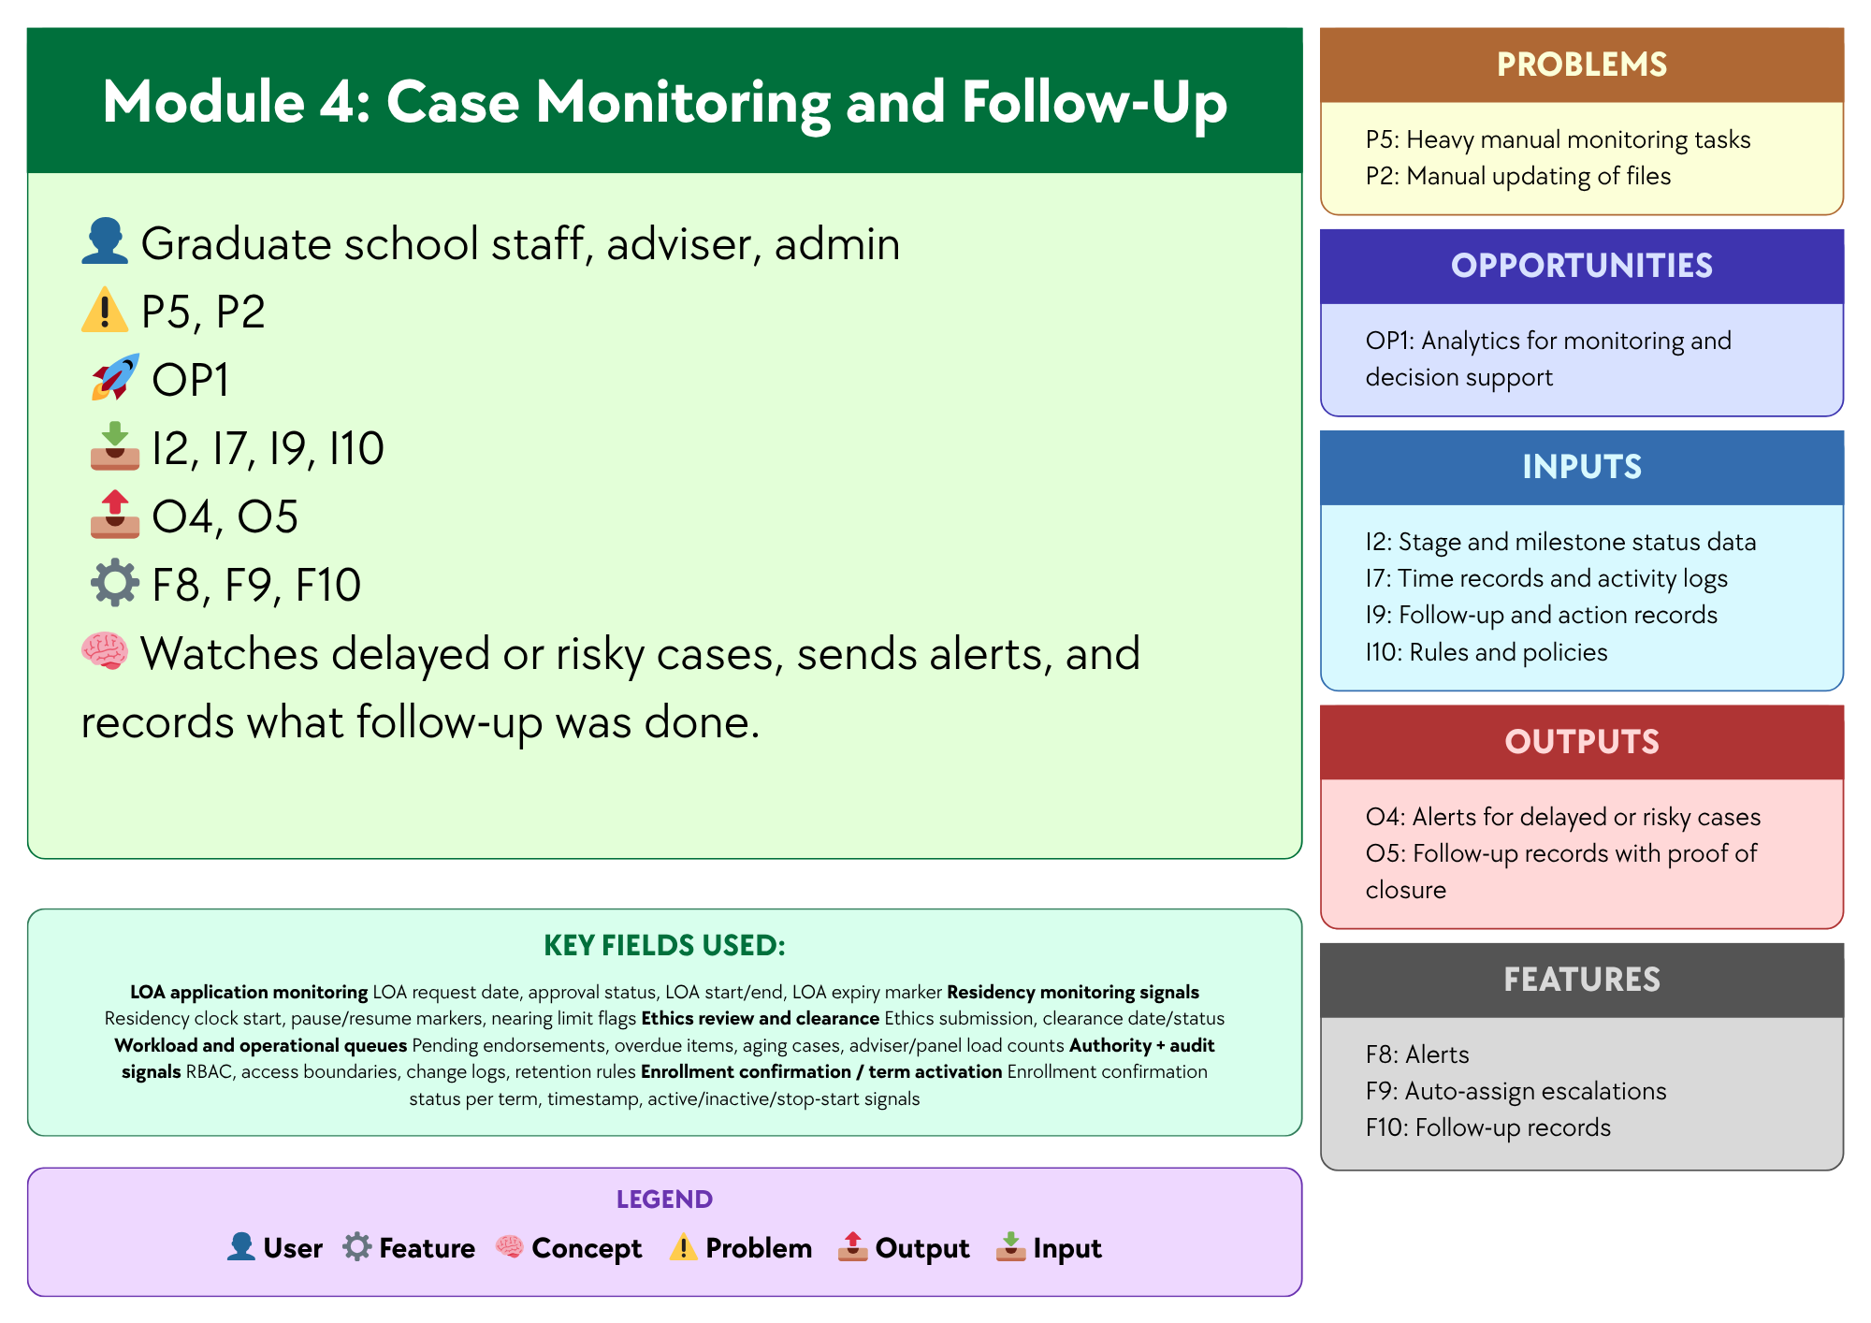

Figure 3.4 Module 4: Case Monitoring and Follow Up
This module focuses on monitoring ongoing cases and identifying those that need attention based on Stage and milestone status data, Time records and activity logs, Follow-up and action records, and Rules and policies. Supported by Alerts, Auto-assign escalations, and Follow-up records, the module helps address Heavy manual monitoring tasks and Manual updating of files by making delayed or risky cases easier to detect and by recording the follow-up actions taken. A monitoring dashboard, automated alert logic, and case tracking database may be used to support this module, since these technologies can help identify cases with delays or inactivity and keep follow-up records updated in a more consistent way. In this way, the module produces Alerts for delayed or risky cases and Follow-up records with proof of closure, helping Graduate School staff and advisers monitor cases more efficiently and respond to issues in a more timely manner.

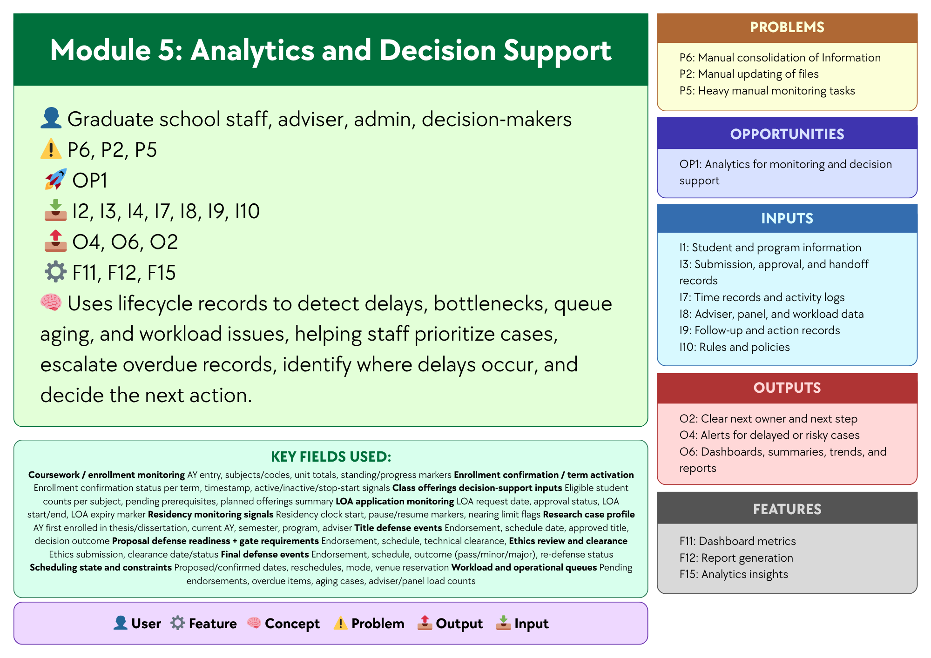

Figure 3.5 Module 5: Analytics and Decision Support
This module analyzes recorded lifecycle data to help the Graduate School better understand student progress and case movement. It uses data such as milestone status, approvals, scheduling records, activity logs, workload data, follow-up actions, and institutional rules and policies. By analyzing these data, the module helps identify patterns like delays, bottlenecks, queue aging, workload issues, and student risk trends. It also supports decisions such as identifying at-risk students, urgent cases, delayed stages, and groups with slower progress or higher attrition. These insights can help staff and decision-makers respond more quickly and appropriately.
The module is also designed to support key decision questions, including:
- Which students are at highest risk of delay, non-completion, or attrition?
- Which students require immediate intervention or priority follow-up?
- Which students are likely to exceed maximum residency based on current progress patterns?
- Which programs, cohorts, or student groups exhibit the slowest completion and highest attrition rates?
- Which lifecycle stages experience the longest delays and most significant bottlenecks?
- Which process areas show the greatest queue aging or case backlog?
- Which students are eligible or nearly ready for the next milestone, defense, or graduation endorsement?
- Which advisers, panels, or coordinators carry the heaviest workload or experience the slowest turnaround times?
- Which students show early signs of academic risk before entering the research stages?
- What completion, delay, and attrition trends should inform policy, resource allocation, and process improvement decisions?
Analytics is needed for these decision questions because reports only present raw or summarized information, while the answers to questions such as who is at risk, which cases need urgent action, where delays are happening, and which programs have slower completion require the system to combine and interpret multiple data points. The Associate Dean also emphasized the need for completion rates, attrition rates, average years to finish, residency tracking, and visibility into the student’s whole lifecycle, which may be presented in reports but require analytical interpretation to reveal patterns, identify risks, and support more informed decision-making.
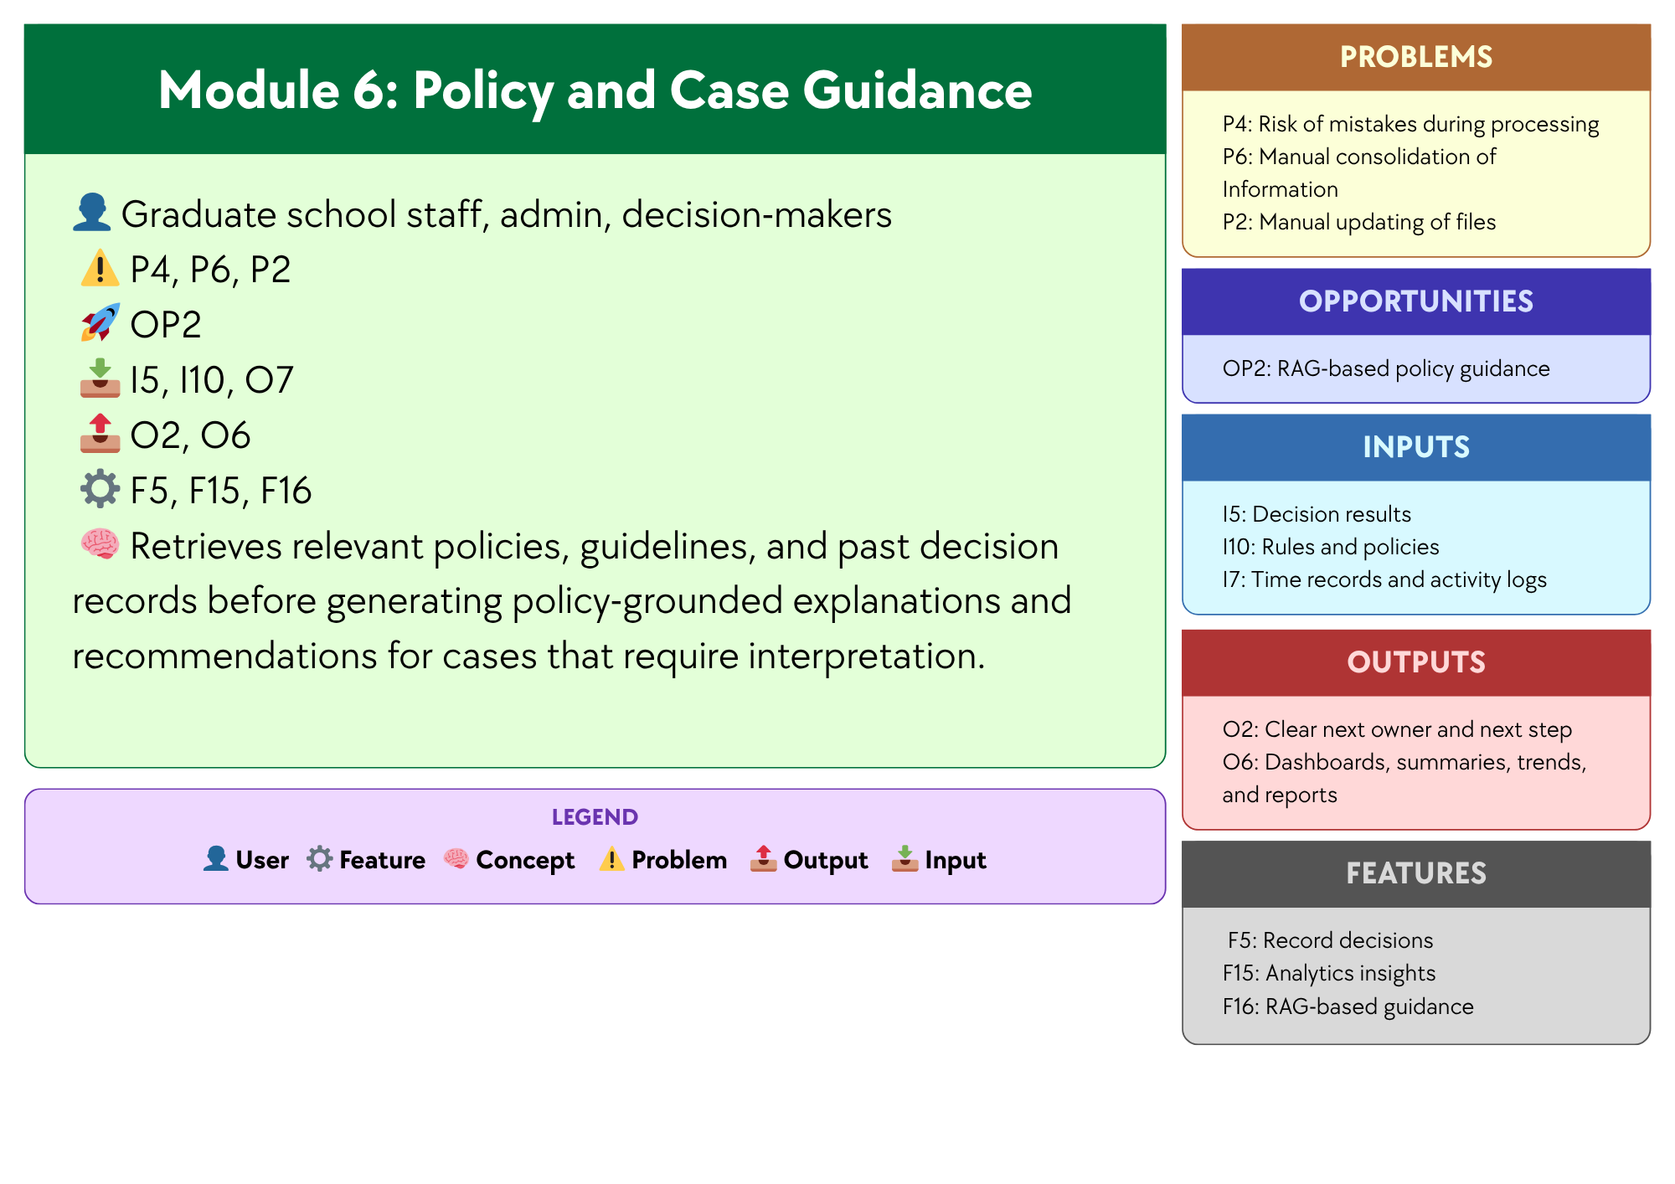

Figure 3.6 Module 6:Policy and Case Guidance
This module focuses on supporting policy and case review for situations that require interpretation in Graduate School operations. Using Graduate School policies, guidelines, forms, and past decision records, and supported by the opportunity to use AI through NotebookLM, the module helps address the time and effort needed to manually search for rules, check related documents, and review similar cases across different files and records. NotebookLM may be used to support this module, since it can work with uploaded reference materials and help users retrieve relevant information before giving explanations and recommendations. In this way, the module produces policy-grounded explanations and recommendations for cases that require interpretation, helping Graduate School staff, administrators, and decision-makers review cases more quickly and more consistently, while final decisions remain with the proper offices and authorized personnel.

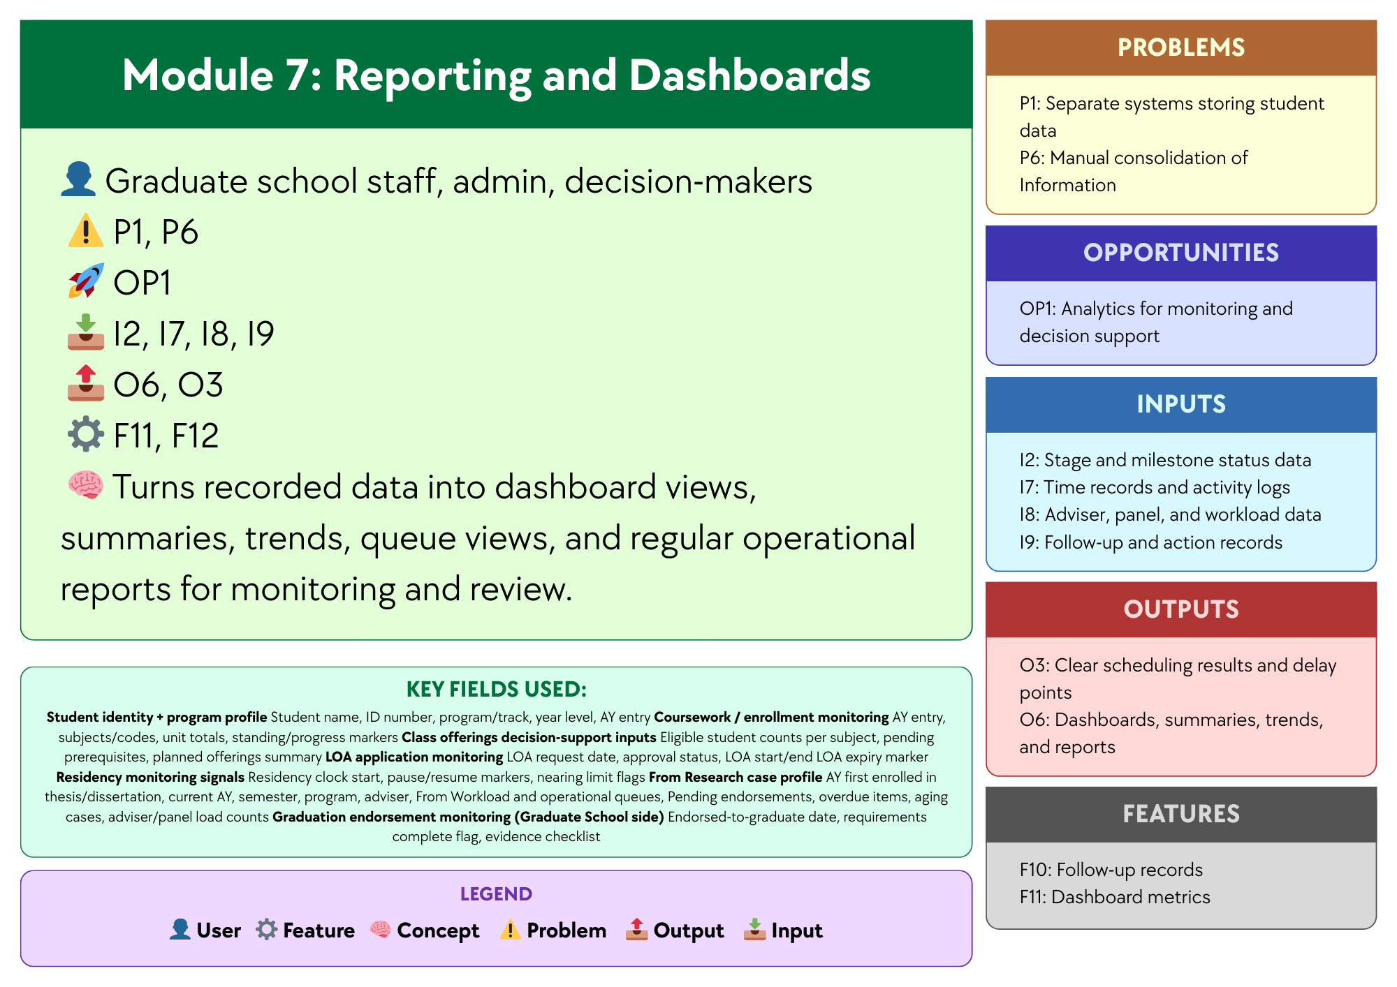

Figure 3.7 Module 7: Reporting and Dashboards
Module 7, Reporting and Dashboards, focuses on presenting recorded case and lifecycle data in a clear and organized form for monitoring, review, and communication. Using Stage and milestone status data, Time records and activity logs, Adviser, panel, and workload data, and Follow-up and action records, and supported by Dashboard metrics and Report generation, the module helps address Separate systems storing student data and Manual consolidation of Information by turning scattered records into summarized views that are easier to access and understand. Dashboard tools, reporting tools, and a centralized database may be used to support this module, since these technologies can gather data from different records and present them through dashboard views, summaries, trends, queue views, and regular operational reports. In this way, the module produces Dashboards, summaries, trends, and reports and Clear scheduling results and delay points, helping Graduate School staff, administrators, and decision-makers review operational conditions more efficiently.

1.6.2 Design Architecture

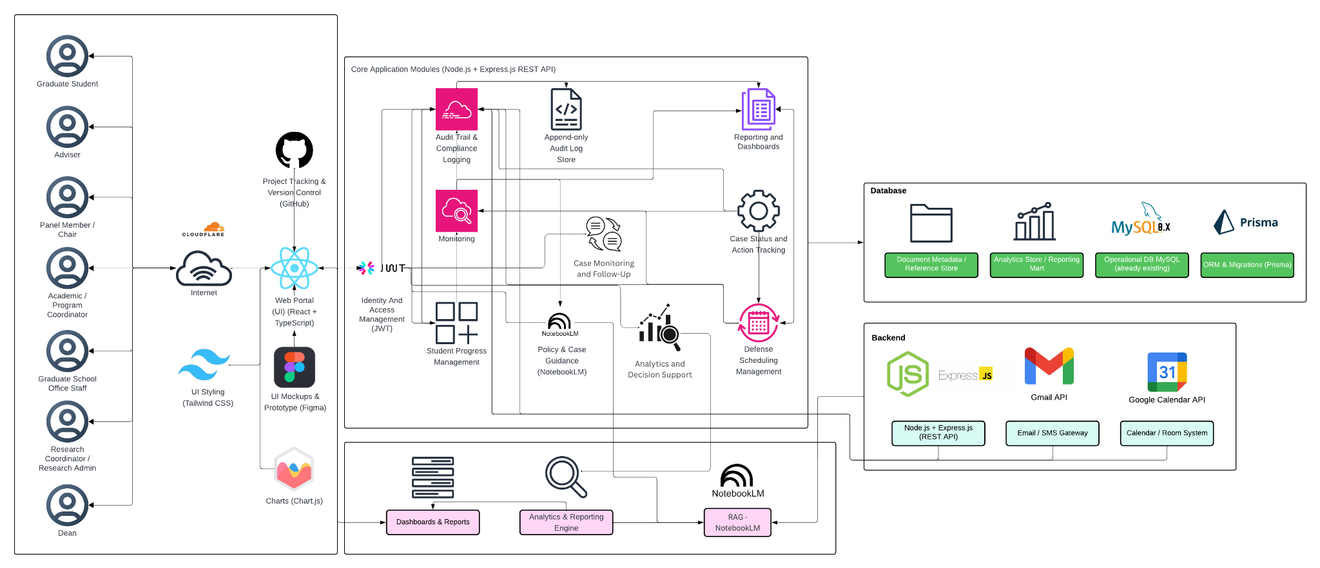

Figure 4. High-Level System Architecture Diagram
Figure 4 shows the high-level architecture of the proposed platform for graduate student lifecycle monitoring and decision support. The architecture begins with the main user groups, namely the graduate student, adviser, panel member or chair, Academic or Program Coordinator, Graduate School Office Staff, Research Coordinator or Research Admin, and the Dean. These users access the system through a web portal built with React and TypeScript, with Tailwind CSS for styling and Chart.js for data visualization. Figma is used for interface design and prototyping, while GitHub is used for project tracking and version control. Access to the platform is controlled through identity and access management using JWT.
At the center of the architecture are the Core Application Modules, built on Node.js and Express.js through a REST API. These modules handle the main functions of the system. The Student Progress Management module shows the student’s current stage, milestone status, and readiness in one place to make progress easier to monitor. The Case Status and Action Tracking module shows who handles the case now, records decisions, and keeps an activity history. The Defense Scheduling Management module tracks scheduling requests, availability, schedule choices, and final schedules. The Case Monitoring and Follow-Up module watches delayed or risky cases, sends alerts, and records what follow-up was done. The Analytics and Decision Support module uses lifecycle records to detect delays, bottlenecks, queue aging, and workload issues, helping staff prioritize cases, escalate overdue records, identify where delays occur, and decide the next action. The Policy and Case Guidance module retrieves relevant policies, guidelines, and past decision records before generating policy-grounded explanations and recommendations for cases that require interpretation. The Reporting and Dashboards module turns recorded data into dashboard views, summaries, trends, queue views, and regular operational reports for monitoring and review. The architecture also includes Audit Trail and Compliance Logging, supported by an append-only Audit Log Store, to keep a traceable record of actions and changes in the system.
The architecture connects these modules to the database layer. This layer includes the Operational Database in MySQL, the Analytics Store or Reporting Mart, and the Document Metadata or Reference Store, with Prisma used for ORM and migrations. This setup keeps daily operational records, reporting data, and document references connected but still organized according to their purpose. The architecture also shows the backend and integration components. The backend is built on Node.js and Express.js.
The use of APIs is also an important part of the architecture. APIs allow the platform to connect with other systems and services so that data does not need to be transferred manually. In the proposed system, APIs may be used to retrieve operational data from existing institutional systems and to support communication and scheduling functions. This helps reduce repeated encoding, lowers the risk of inconsistent records, and supports a more connected monitoring process across Graduate School activities.

Two API-based integrations are especially relevant in the design. The Google Calendar API may be used to support defense scheduling, meeting coordination, and possible room or calendar checks. This can help the system record and manage schedule requests in a more organized way. The Gmail API may be used to support email notifications, follow-up messages, and communication related to tasks, reminders, or case updates. These integrations make it easier for the platform to support actual Graduate School workflows, especially in areas where scheduling and communication are part of day-to-day monitoring.
For the proposed design, the study uses a RAG-based decision support approach for policy and case guidance. In this setup, the assistant retrieves relevant Graduate School policies, guidelines, forms, past case references, and other approved documents before generating any response. This means the assistant does not rely on free-form answers alone, but instead uses retrieved sources and system-generated indicators as the basis for its guidance. NotebookLM may be used as a practical prototyping environment for organizing and querying approved reference materials, but it is not treated as the core backend service or the source of truth of the platform. Official status signals, computed indicators, and rule-based recommendations remain generated by the system backend and database from validated records. In this way, the RAG layer serves as a retrieval and explanation tool for authorized users, while final decisions remain with the proper offices and authorized personnel.
Overall, Figure 4 shows that the proposed platform is designed as a web-based monitoring and decision-support system built around core modules, structured records, reporting tools, and controlled integrations. It supports multiple Graduate School roles while keeping lifecycle data, milestone tracking, case records, scheduling, alerts, and reporting within one connected system view. By combining a centralized platform, API-supported integration, and policy-grounded AI guidance through NotebookLM, the design supports faster monitoring, better record visibility, and more consistent administrative review.

1.7 Scope and Limitations
To avoid scope creep, this study uses a focused and depth-oriented scope. The prototype centers on a Graduate School monitoring and process coordination layer that supports milestone definitions, role-based task queues, dashboards and reports, event logging for analytics, and prescriptive decision support outputs. Its goal is to provide clear visibility and traceability of graduate student progress across lifecycle stages and research milestones, while also supporting day-to-day Graduate School follow-up through validated process signals and recorded timestamps.
This scope reflects the current AS-IS setup, where lifecycle signals and process steps already exist but are spread across spreadsheets, email coordination, and separate tools. The system will represent allowed progress indicators, such as completion markers, incomplete status flags, readiness checks, and document or evidence checkpoints. It will also formalize key process handoffs, such as next-step ownership and task routing. However, it will not replace institutional systems used for admissions processing, enrollment transactions, grading, learning management, registrar processing, or accounting and billing. Prescriptive analytics for decision support will be limited to rule-based recommendations based on allowed process events, timestamps, and encoded Graduate School policies. Final decisions and approvals will remain with authorized Graduate School stakeholders.

1.7.1 Scope

1.7.1.1 User Scope
The platform is intended for authorized Graduate School stakeholders responsible for monitoring, follow-up, and coordination of graduate student progress. These users include Graduate School administrative staff, coordinators, program-level coordinators, research advisers, panel members, research coordinators, designated reviewers or approvers, and the Graduate School dean. Each user accesses the platform through role-based dashboards that display lifecycle status, pending actions, submitted requirements, and scheduling information relevant to their responsibilities.
The platform supports graduate programs offered by the University of St. La Salle – Bacolod Graduate School, including programs under the following academic clusters:
- Arts and Sciences
- Business
- Education
- Engineering and Technology
- Nursing
Student coverage includes enrolled graduate students undergoing coursework, research milestones, or completion requirements within the Graduate School. The platform monitors lifecycle progression from admission onboarding to graduation endorsement within Graduate School processes.

1.7.1.2 Process Scope
The platform supports monitoring and coordination of the following Graduate School process areas:
- Admission Monitoring and Process Coordination – tracking requirements submission status signals, intake verification, enrollment confirmation handoff, and Graduate School onboarding.
- Enrollment Monitoring and Process Coordination – monitoring enrollment status, adding and dropping tracking, enrollment confirmation, offerings planning support, and course audit signals for program requirements.
- Coursework Monitoring and Process Coordination – monitoring student progress during coursework stages, including schedule visibility, module tracking, allowed monitoring signals for grade or standing, and readiness checks for transition to thesis or dissertation milestones.
- Leave of Absence and Readmission Monitoring – recording LOA applications, tracking pause in residency as a monitoring signal, and monitoring readmission processing for returning students.
- Thesis and Dissertation Monitoring and Defense Coordination – tracking research milestones such as adviser designation, title defense, proposal defense, revision cycles, manuscript finalization, defense scheduling, final defense completion, and evidence tracking.
- Practicum Monitoring (Program-Dependent) – tracking practicum hours, schedule monitoring, and related documentation for programs that require practicum completion.
- Withdrawal Monitoring – recording withdrawal requests, confirming withdrawal actions, and monitoring handoff closure steps.
- Graduation Endorsement Monitoring – verifying completion requirements, preparing endorsement lists on the Graduate School side, and handing off endorsed cases to the Registrar for final graduation processing.

1.7.1.3 Data Scope
The platform captures and uses only the operational data needed to support lifecycle monitoring and process coordination. These data elements include:
- Student lifecycle status signals and stage markers.
- Milestones, requirements, and evidence checklists linked to each stage.
- Process events such as submitted, received, verified, returned, approved, scheduled, and rescheduled.
- Ownership records and task assignments identifying the stakeholder responsible for the next action.
- Event timestamps and key dates used to support monitoring indicators such as time-in-stage and cycle-time tracking.
- Prescriptive analytics and decision-support signals derived from encoded policies and allowed process logs, such as next-step prompts, overdue flags, and escalation prompts.

1.7.1.4 Key Performance Indicators (KPIs) of the Conceptual Framework
To align the KPI section with the current conceptual framework and the Existing (AS-IS) vs Proposed (TO-BE) System section, the KPIs are grouped into two categories. The first category covers inherent system modules, which support access control, accountability, and secure use of the platform across all functions. The second category covers the new system modules (TO-BE), which directly address the Graduate School’s monitoring and processing needs. This grouping keeps the seven operational TO-BE modules unchanged while still allowing User and Access Management and Audit Trail and Accountability to be included in the KPI section.

A. Inherent System Modules
User and Access Management KPI
KPI | Target | Measurement Method | Reporting Frequency
Access control enforcement rate | 100% pass for all defined role-permission test cases | (Passed role-permission test cases ÷ Total defined role-permission test cases) × 100 | Every test cycle

Table 3.1 User and Access Management KPI
The User and Access Management KPI measures whether access to the platform is limited to the correct roles and permissions. Since the proposed system uses role-based access control, access restrictions must work consistently across modules and user types. This KPI is supported by ISO/IEC 25010 for system quality requirements and OWASP ASVS for access control testing.
Audit Trail and Accountability KPI
KPI | Target | Measurement Method | Reporting Frequency
Audit event coverage | 100% of defined auditable actions create timestamped log entries | (Auditable actions with valid timestamped logs ÷ Total defined auditable actions tested) × 100 | Every test cycle

Table 3.2 Audit Trail and Accountability KPI
The Audit Trail and Accountability KPI measures whether important actions in the system create timestamped logs that support accountability and traceability. These logs are needed to confirm who updated what, when the update happened, and what action was taken. This KPI is supported by ISO/IEC 25012 for data quality and NIST SP 800-53 for audit logging and accountability controls.
A. New System Modules (TO-BE)
Module 1: Student Progress Management KPI
KPI | Target | Measurement Method | Reporting Frequency
Required monitoring field completion rate | 100% of active prototype records have all required monitoring fields | (Active prototype records with all required monitoring fields ÷ Total active prototype records) × 100 | Every academic term

Table 3.3 Module 1: Student Progress Management KPI
This KPI checks whether the system records the required monitoring information needed to maintain a clear view of student progress. These records include lifecycle stage, completion status, curriculum tag, and AY/Sem taken markers. This KPI is based on the confirmed monitoring needs discussed in the 2nd Meeting Transcript Confirmation w/ Sir Eddie De Paula and is supported by ISO/IEC 25012 for completeness of records.
Module 2:Case Status and Action Tracking KPI
KPI | Target | Measurement Method | Reporting Frequency
Next-action ownership coverage | 100% of active in-scope cases have an assigned next-action owner | (Active in-scope cases with assigned next-action owner ÷ Total active in-scope cases) × 100 | Weekly

Table 3.4 Module 2: Case Status and Action Tracking KPI
This KPI checks whether active cases have a clearly assigned next-action owner. This helps confirm that handoffs, follow-ups, and decisions are visible and not left unclear across roles. This KPI is based on the confirmed role ownership and process needs documented in the 2nd Meeting Transcript Confirmation w/ Sir Eddie De Paula.
Module 3: Defense Scheduling Management KPI
KPI | Target | Measurement Method | Reporting Frequency
Scheduling record completeness | ≥ 90% of scheduling cases have both request and outcome timestamps | (Scheduling cases with complete request and outcome timestamps ÷ Total scheduling cases) × 100 | Per defense cycle

Table 3.5 Module 3: Defense Scheduling Management KPI
This KPI checks whether the required checklist items for a student’s current stage are recorded in the system. It supports monitoring of submissions, revisions, missing evidence, and linked document records. This KPI is supported by the Graduate School Research Protocol for required forms and stage rules, the 2nd Meeting Transcript Confirmation w/ Sir Eddie De Paula for confirmed process needs, and ISO/IEC 25012 for completeness of records.
Module 4: Case Monitoring and Follow-Up KPI
KPI | Target | Measurement Method | Reporting Frequency
Follow-up closure logging rate | ≥ 90% of flagged cases have a recorded follow-up action and closure status | (Flagged cases with recorded follow-up and closure status ÷ Total flagged cases) × 100 | Monthly

Table 3.6 Module 4: Case Monitoring and Follow-Up KPI
This KPI checks whether scheduling cases contain the records needed to monitor requests, outcomes, and delays. These records must be complete enough to measure scheduling cycle time. This KPI is supported by the Graduate School Research Protocol for scheduling rules and ISO/IEC 25012 for completeness and timeliness of scheduling records.
Module 5: Analytics and Decision Support
KPI | Target | Measurement Method | Reporting Frequency
Analytics report generation rate | ≥ 90% of required analytics outputs are successfully generated from recorded lifecycle data | (Number of required analytics outputs successfully generated ÷ Total required analytics outputs) × 100 | Monthly

Table 3.7 Module 5: Monitoring and Follow-ups KPI
This KPI checks whether flagged or delayed cases have recorded follow-up actions and closure status. It supports LOA monitoring, residency watchlists, alerts, and intervention tracking. This KPI is based on the confirmed monitoring needs in the 2nd Meeting Transcript Confirmation w/ Sir Eddie De Paula and on Google SRE guidance for tracking follow-up timing and operational response measures.
Module 6: Policy and Case Guidance KPI
KPI | Target | Measurement Method | Reporting Frequency
Policy-grounded response match rate for decision-support outputs | 100% match on the defined prototype rule and reference test set | (Decision-support outputs that correctly match the approved rule and retrieved reference test set ÷ Total rule-based test cases) × 100 | Every test cycle

Table 3.8 Module 6: Policy and Case Guidancet KPI
This KPI checks whether the decision-support assistant produces outputs that are consistent with the defined prototype rules and grounded on the retrieved approved reference documents. Since the assistant only supports monitoring and processing, its outputs must remain aligned with authorized rules, policies, and reference materials and must not replace authorized decisions. This KPI is based on the confirmed scope in the 2nd Meeting Transcript Confirmation w/ Sir Eddie De Paula and is supported by ISO/IEC 25010 for consistency and functional suitability.
Module 7: Reporting and Dashboardss KPI
KPI | Target | Measurement Method | Reporting Frequency
Required report availability | 100% of the agreed report set is available in the prototype | (Available agreed reports ÷ Total agreed report set) × 100 | Every academic term

Table 3.9 Module 6: Reporting and Dashboards KPI
This KPI checks whether the agreed report set is available in the prototype. These reports include subject needs, graduation candidate lists, LOA monitoring, residency tracking, and completion summaries. This KPI is based on the confirmed reporting needs in the 2nd Meeting Transcript Confirmation w/ Sir Eddie De Paula and is supported by ISO/IEC 25010 for consistent system outputs.
Reference labels used in the KPI table
Reference | Source | Brief explanation
SDP | 2nd Meeting Transcript Confirmation w/ Sir Eddie De Paula | Used for the confirmed AS-IS process, role ownership, monitoring needs, reporting needs, and scope boundaries.
GSRP | Graduate School Research Protocol | Used for required forms, stage rules, document checkpoints, and scheduling rules.
ISO 25012 | ISO/IEC 25012 Data Quality Model | Used for data quality measures such as completeness, consistency, and timeliness of records.
ISO 25010 | ISO/IEC 25010 System and Software Quality Model | Used for measurable system and software quality requirements.
Google SRE | Google Site Reliability Engineering guidance | Used for alert timing, follow-up timing, and target-setting ideas such as service level indicators and objectives.
OWASP ASVS | OWASP Application Security Verification Standard | Used to guide access control testing.
NIST SP 800-53 | NIST Security and Privacy Controls | Used to guide audit logging and accountability checks.

Table 4. Reference labels used in the KPI table
Table 4 explains the short reference labels used in the KPI table. These labels point to the main documents and standards used to support the expected outputs, KPI choices, and initial targets of the conceptual framework modules.
Note: The KPI types used in this study are aligned with recognized references. ISO/IEC 25012, which is an international standard for data quality in structured computer systems, supports measures related to completeness, consistency, and timeliness. ISO/IEC 25010, which is an international quality model for software and systems, supports defining measurable quality requirements. ISO 9241-11, which is a usability standard, explains usability in terms of effectiveness, efficiency, and satisfaction. For operational targets, Google SRE guidance, which is Google’s approach to service reliability, uses SLIs or service level indicators as measures and SLOs or service level objectives as target values. For security controls, OWASP ASVS, which is an open standard for testing web application security controls, can guide access control testing. For audit-related controls, NIST SP 800-53 and NIST SP 800-53A, which are NIST guidelines for security controls and their assessment, can guide what should be logged and how those controls can be checked.

1.7.1.2 Existing (AS-IS) vs Proposed (TO-BE) System
Module | AS-IS (Existing System) | TO-BE (Prototype)
Module 1: Student Progress Management | Student progress is tracked across spreadsheets, monitoring sheets, email updates, and separate records. There is no single view of where a student is in the graduate lifecycle or whether the student is ready for the next stage. | One monitoring view shows the student’s current lifecycle stage, milestone status, readiness checks, key status markers, required next steps, and recorded timestamps.
Module 2: Case Status and Action Tracking | Case actions, handoffs, and decisions are often handled through manual follow-up, email coordination, and person-to-person checking. It is not always clear who currently owns the case, what action was taken, or what should happen next. | Role-based task queues and case records show the current owner, recorded actions, decision results, handoff history, and the next required step for each case.
Module 3: Defense Scheduling Management | Defense scheduling is mainly coordinated through email and manual follow-up. Availability, schedule requests, delays, reschedules, and final outcomes are not consistently recorded in one place. | Scheduling requests, availability, assigned schedules, confirmations, reschedules, and outcomes are recorded as structured scheduling records with dates and status updates.
Module 4: Case Monitoring and Follow Up | Monitoring depends on manual checking, reminders, and role-maintained records. Delayed or risky cases may only be noticed after repeated follow-up, and proof of closure is not always easy to confirm. | Alerts, flagged cases, follow-up actions, escalation records, and proof of closure are tracked in one place to support faster monitoring and more consistent follow-through.
Module 5: Analytics and Decision Support | Staff often need to manually consolidate information from separate files, records, and updates before they can identify delays, bottlenecks, workload issues, or cases needing attention. | Dashboard metrics, summaries, trends, and analytics insights are generated from structured lifecycle data to help identify delays, workload concerns, bottlenecks, and priority cases.
Module 6: Policy and Case Guidance | Status questions, policy checking, and next-step guidance depend on manual review of forms, policy documents, previous records, spreadsheets, and emails. This takes time and may vary depending on who is doing the review. | A RAG-based assistant retrieves relevant policy documents, guidelines, and past case references, then produces grounded summaries, case guidance, and suggested next steps to support monitoring and processing. Final decisions still remain with authorized personnel.
Module 7: Reporting and Dashboards | Reports are prepared manually from separate files and records. Definitions may vary, and staff often need to consolidate data before reports can be used for monitoring and review. | Dashboards and reports are generated from the same structured data source, making operational views, summaries, trends, and monitoring reports more consistent and easier to prepare.

Table 5. Existing system (as-is) vs proposed system (to-be)
Table 5 compares the current setup and the proposed prototype based on the updated modules in the conceptual framework. The AS-IS side shows that monitoring, case handling, scheduling, follow-up, policy checking, and reporting are still spread across spreadsheets, forms, email coordination, policy documents, and manual checking. The TO-BE side shows how each module is intended to organize these activities into a more consistent monitoring and processing platform. Through structured records, analytics, dashboards, and RAG-based policy and case guidance, the proposed prototype is designed to improve visibility, consistency, and support for graduate student lifecycle management.

1.7.2 Limitations
The project is limited to Graduate School monitoring and decision support. It will not replace institutional systems or offices that handle official records, transactions, or financial processes. Specifically:
- The system will not replace AIMS admissions processing. It will only monitor status signals and handoffs where allowed.
- The system will not handle official enrollment transactions, grade encoding, or learning management functions. It will only represent allowed monitoring signals, such as completion markers, incomplete status flags, and readiness checks.
- The system will not replace Registrar functions, official academic records, transcript processing, or official graduation processing. Graduation status remains under Registrar ownership.
- The system will not implement accounting, billing, or payment processing, and it will not manage financial approvals.
- The system will not track private adviser-student communication, such as personal message threads. Monitoring will focus only on submissions, decisions, schedules, required evidence, and validated status signals.
- Predictive analytics that depend on unavailable or restricted data will not be implemented. Reporting will be limited to data that can be captured within the platform’s privacy and access limits.
- Program-dependent components, such as practicum, will only be included where the practicum are confirmed as part of the graduate program. In the validated notes, practicum was confirmed for Psychology and MSGC, and the current process is still paper-based with multiple certificates and MOAs where needed.

1.8 Significance of the Study
This study is significant because it helps improve how Graduate School monitoring and processing can be handled across the student lifecycle. The proposed platform makes student progress easier to see, supports coordination across roles, and improves reporting by capturing clear status signals, next-action ownership, and timestamps. It also keeps access to sensitive records controlled through role-based access and audit-ready logging (Datu, 2022; Doce & Ching, 2018; Tanate-Lazo, 2021).
For the University of St. La Salle – Bacolod Graduate School. The platform supports monitoring of student standing across lifecycle stages and research milestones. This can reduce the need to reconstruct status manually from spreadsheets, forms, and email coordination. It also supports queue-based visibility by showing what is pending, overdue, or waiting for action. This is important because the confirmed notes show that the Graduate School still needs reports such as subject needs, graduating student lists, LOA monitoring, and residency tracking, and that some reports still require manual checking and year counting from AIMS exports. The same notes also show that the current view is often per student in spreadsheets rather than a consolidated group view, which makes it harder to support class planning and status checking at the program level. In this sense, the study is significant to the Graduate School because it directly addresses the current difficulty of monitoring student progress, preparing reports, and following up cases using scattered records and manual processing.
For other educational institutions. The study provides a reference for how graduate lifecycle monitoring can be organized into one operational model, from admission up to graduation endorsement. It shows how status signals, exceptions, and role-based coordination can be structured in a way that supports term-level decisions and reporting needs. This is especially useful for institutions where monitoring is still spread across spreadsheets, forms, and email coordination (CHED Region IV-B MIMAROPA, 2018; Grooms et al., 2016). It is also useful for schools that want to improve visibility without replacing official admissions, Registrar, or accounting systems, since the confirmed scope in the Graduate School notes clearly keeps the platform as a monitoring and support layer only.
For academic purposes and other researchers. This study contributes an applied systems development perspective by translating graduate lifecycle operations into structured monitoring elements such as states, events, queues, and time-based indicators. It also shows how practical Graduate School records, such as monitoring templates, research protocol forms, and signed process validations, can be used as the basis for a monitoring and decision-support platform. In addition, it highlights the importance of privacy-aware design in educational monitoring platforms by showing how privacy and accountability can be supported through role-based access control and auditability mechanisms (Datu, 2022; Doce & Ching, 2018; Tanate-Lazo, 2021). The study may also support future research on how visibility, traceability, and milestone-based monitoring relate to student progress, delays, and completion in graduate education (van Lill, 2024; Willess, 2023; Young et al., 2024).

